MAN 4720 Spring 2010 Assessment Report
By Majors for the College Of Business

Prepared by: Sue A. Dahmus, Ph.D. Date: May, 2010

Introduction

Instructors were asked to measure their students’ critical/analytical thinking scores, technical skills, and written communication skills using a common assignment based on a Porter’s Industry Analysis. In addition, instructors were asked to measure each student’s oral communication skills.

In order to assess MAN 4720 content/declarative knowledge, the instructors were provided with questions (for three textbooks) covering the five required content areas.

Assessment Variables

Variables

Critical/Analytical Thinking Skills (CT)

Technical Skills (TS)

Written Communication Skills (WC)

Oral Communication Skills (OC)

Declarative Knowledge (DK)

Scoring Rubric

Skills exceed expectations = 3
Skills meet expectations = 2
Skills below expectations = 1

page 1

Spring 2010

Summary of Means by Major:

CT TS WC OC DK Grade Grade

Major___ N Mean Mean Mean Mean Mean Mean Range
Accounting 92 2.1 2.1 2.2 2.0 2.1 85.4 62-100
Economics 13 2.2 2.2 2.2 2.1 2.2 86.1 75-100
Finance 59 2.1 2.1 2.1 1.9 2.1 83.2 55-100
Hosp & Tour 8 1.9 1.9 1.9 1.9 2.1 82.3 63-98
MIS 18 2.1 1.8 2.1 1.7 2.0 82.5 73-94
IB 35 2.1 2.0 1.8 2.1 2.0 82.3 57-94
Management 116 2.1 2.1 2.1 2.3 1.9 83.4 19-100
Marketing 100 2.2 2.2 2.2 2.2 2.0 84.7 40-100
Small Bus 9 2.3 1.9 2.1 2.1 2.4 81.8 40-96

Overall 371 2.1 2.0 2.1 2.1 2.0 83.4 19-100

____________________________________________________________________________________________________________

Fall 2009

Summary of Means by Major:

CT TS WC OC DK Grade Grade

Major___ N Mean Mean Mean Mean Mean Mean Range
Accounting 89 2.1 2.1 2.1 2.2 2.0 83.9 26-100
Economics 12 1.9 1.9 1.9 2.2 2.0 85.6 77-94
Finance 65 2.2 2.2 2.3 2.3 2.1 85.9 64-100
Hosp & Tour 4 2.0 2.3 2.0 2.5 1.8 76.7 72-83
Real Estate 5 2.4 2.0 2.4 2.2 2.2 86.6 80-95
MIS 7 2.2 2.2 2.2 2.1 1.9 84.2 76-97
IB 41 2.2 2.2 2.1 2.3 2.0 84.0 50-99
Management 131 2.0 2.0 2.0 2.3 2.0 83.8 46-99
Marketing 106 2.1 2.1 2.1 2.2 2.0 84.6 16-99
Small Bus 8 1.5 1.5 1.9 2.4 1.8 83.4 73-93

Overall 386 2.1 2.1 2.1 2.3 2.0 83.9 16-100

Page 2

Fall 2009

Summary of Means by Major:

CT TS WC OC DK Grade Grade

Major___ N Mean Mean Mean Mean Mean Mean Range
Accounting 89 2.1 2.1 2.1 2.2 2.0 83.9 26-100
Economics 12 1.9 1.9 1.9 2.2 2.0 85.6 77-94
Finance 65 2.2 2.2 2.3 2.3 2.1 85.9 64-100
Hosp & Tour 4 2.0 2.3 2.0 2.5 1.8 76.7 72-83
Real Estate 5 2.4 2.0 2.4 2.2 2.2 86.6 80-95
MIS 7 2.2 2.2 2.2 2.1 1.9 84.2 76-97
IB 41 2.2 2.2 2.1 2.3 2.0 84.0 50-99
Management 131 2.0 2.0 2.0 2.3 2.0 83.8 46-99
Marketing 106 2.1 2.1 2.1 2.2 2.0 84.6 16-99
Small Bus 8 1.5 1.5 1.9 2.4 1.8 83.4 73-93

Overall 386 2.1 2.1 2.1 2.3 2.0 83.9 16-100

____________________________________________________________________________________________________________

Summer 2009

Summary of Means by Major:

CT TS WC OC DK Grade Grade

Major___ N Mean Mean Mean Mean Mean Mean Range
Accounting 69 2.1 2.1 2.3 2.1 2.1 85.8 52-99
Economics 6 2.5 1.8 1.8 1.8 2.2 84.8 77-97
Finance 37 2.2 2.0 2.0 2.0 1.8 84.9 74-97
Hosp & Tour 7 1.9 2.0 1.9 2.0 1.6 83.0 68-94
Real Estate 1 2.0 2.0 3.0 3.0 1.0 81.0
MIS 11 2.1 2.1 2.2 2.2 1.6 83.1 73-96
IB 17 1.9 1.9 2.1 2.1 1.5 83.5 76-90
Management 82 2.2 2.2 2.2 2.3 1.8 86.1 50-99
Marketing 58 2.1 2.2 2.3 2.2 1.8 85.2 32-96
Small Bus 5 2.6 2.4 2.4 2.4 1.8 89.8 84-99

Overall 241 2.1 2.1 2.2 2.2 1.9 85.1 32-99
________________________________________________________________________________________________________________________________________________

Page 3

Spring 2009

Summary of Means By Major:

CT TS WC OC DK Grade Grade

Major___ N Mean Mean Mean Mean Mean Mean Range
Accounting 96 2.0 2.0 2.2 2.3 2.0 86.8 73-100
Economics 2 1.5 2.0 2.0 2.5 2.0 85.1 80-90
Finance 74 2.0 2.1 2.2 2.2 1.9 86.1 55-100
Hosp & Tour 15 1.7 1.9 1.9 1.9 1.8 83.5 67-99
Real Estate 6 1.7 2.2 2.3 2.0 1.8 84.8 74-98
MIS 18 1.6 1.9 2.0 2.1 1.8 83.1 73-92
IB 28 1.9 1.9 1.9 2.2 2.1 84.6 73-96
Management 148 2.0 2.0 2.1 2.3 1.9 84.7 35-99
Marketing 126 2.1 2.1 2.1 2.3 1.9 85.4 67-99
Small Bus 2 1.0 1.0 2.0 2.5 1.5 81.5 80-83

Overall 450 1.9 2.0 2.1 2.1 2.1 84.8 35-100
_______________________________________________________________________________________________________________________________________________
_______________________________________________________________________

Page 4
Spring 2010 Semester MAN 4720
Assessment Information for Accounting Majors

Spring 2010 Correlations for Accounting Majors

CT TS WC OC DK
TS .72
WC .71 .71
OC .36 .36 .33
DK .62 .59 .58 .40
Grade .64 .69 .71 .58 .68

Spring 2010 Frequencies for Accounting Majors

CT Frequency__% TS Frequency__% WC Frequency__%
1 24 26 1 25 27 1 14 15
2 35 38 2 35 38 2 44 48
3 33 36 3 32 35 3 34 37

OC Score Frequency__% DK Score Frequency__%
1 22 24 1 23 25
2 45 48 2 36 39
3 26 28 3 34 37

Spring 2010 Accounting Majors
CHI-SQUARE BY MEASURE and FINAL GRADE

Critical | Grade
Thinking | A | B | C | D | F
Score
1 | 0 | 7 | 14 | 3 | 0
2 | 9 | 16 | 10 | 0 | 0
3 | 22 | 11 | 0 | 0 | 0

Page 5
Technical | Grade
Skills | A | B | C | D | F
Score
1 | 0 | 5 | 17 | 3 | 0
2 | 11 | 17 | 7 | 0 | 0
3 | 20 | 12 | 0 | 0 | 0

Written Communications | Grade
Skills | A | B | C | D | F
Score
1 | 0 | 1 | 10 | 3 | 0
2 | 8 | 23 | 13 | 0 | 0
3 | 23 | 10 | 1 | 0 | 0

Oral Communications | Grade
Skills | A | B | C | D | F
Score
1 | 1 | 10 | 9 | 2 | 0
2 | 14 | 14 | 16 | 1 | 0
3 | 16 | 10 | 0 | 0 | 0

Declarative Knowledge | Grade
Skills | A | B | C | D | F
Score
1 | 0 | 4 | 17 | 2 | 0
2 | 9 | 18 | 8 | 1 | 0
3 | 22 | 12 | 0 | 0 | 0

Page 6
Fall 2009 Semester MAN 4720
Assessment Information for Accounting Majors

Fall 2009 Correlations for Accounting Majors

CT TS WC OC DK
TS .85
WC .75 .72
OC .20 .19 .17
DK .24 .33 .28 -.15
Grade .55 .55 .54 .18 .42

Fall 2009 Frequencies for Accounting Majors

CT Frequency__% TS Frequency__% WC Frequency__%
1 22 25 1 20 23 1 19 21
2 38 43 2 38 43 2 43 48
3 29 33 3 31 35 3 27 30

OC Score Frequency__% DK Score Frequency__%
1 8 10 1 26 29
2 45 58 2 43 47
3 24 31 3 22 24

Fall 2009 Accounting Majors
CHI-SQUARE BY MEASURE and FINAL GRADE

Critical | Grade
Thinking | A | B | C | D | F
Score
1 | 2 | 8 | 7 | 3 | 2
2 | 7 | 23 | 8 | 0 | 0
3 | 22 | 5 | 2 | 0 | 0

Page 7
Technical | Grade
Skills | A | B | C | D | F
Score
1 | 2 | 8 | 5 | 3 | 2
2 | 5 | 22 | 11 | 0 | 0
3 | 24 | 6 | 1 | 0 | 0

Written Communications | Grade
Skills | A | B | C | D | F
Score
1 | 0 | 9 | 6 | 2 | 2
2 | 13 | 20 | 9 | 1 | 0
3 | 18 | 7 | 2 | 0 | 0

Oral Communications | Grade
Skills | A | B | C | D | F
Score
1 | 2 | 4 | 1 | 1 | 0
2 | 9 | 20 | 11 | 3 | 2
3 | 12 | 10 | 2 | 0 | 0

Declarative Knowledge | Grade
Skills | A | B | C | D | F
Score
1 | 3 | 12 | 7 | 2 | 2
2 | 12 | 19 | 10 | 2 | 0
3 | 16 | 5 | 1 | 0 | 0

Page 8
Summer 2009 Semester MAN 4720
Assessment Information for Accounting Majors

Summer 2009 Correlations for Accounting Majors

CT TS WC OC DK
TS .70
WC .48 .51
OC .35 .19 .31
DK .46 .46 .32 .01
Grade .38 .41 .52 .22 .63

Summer 2009 Frequencies for Accounting Majors

CT Frequency__% TS Frequency__% WC Frequency__%
1 13 19 1 14 20 1 5 7
2 33 48 2 35 51 2 40 58
3 23 33 3 20 29 3 24 35

OC Score Frequency__% DK Score Frequency__%
1 8 14 1 14 20
2 36 61 2 34 49
3 15 25 3 22 31

Summer 2009 Accounting Majors

CHI-SQUARE BY MEASURE and FINAL GRADE

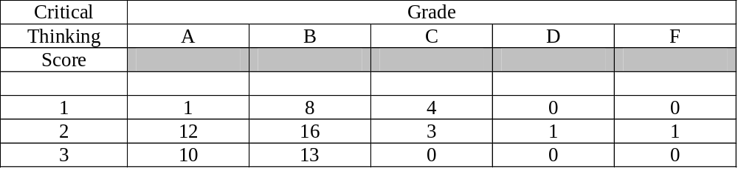
Page 9
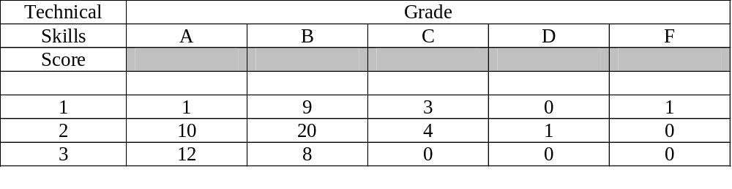

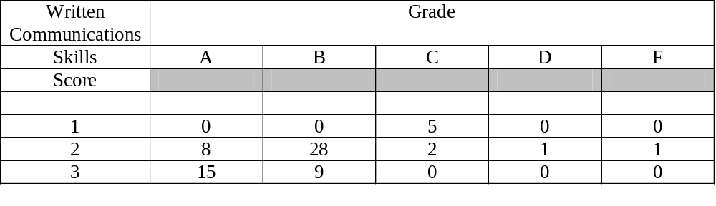

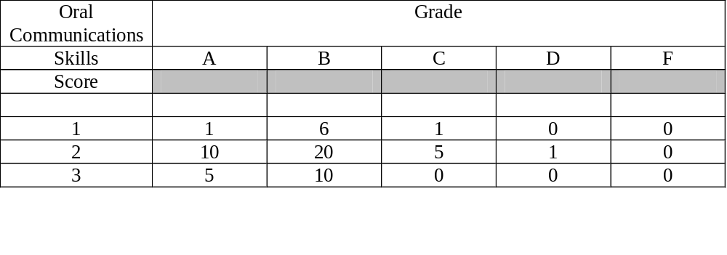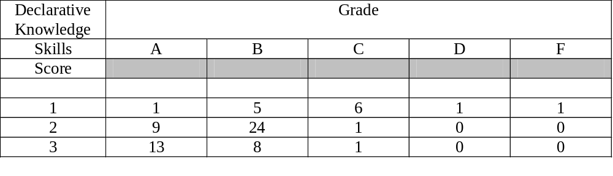________________________________________________________________________________________________________________________________________________

Page 10
Spring 2009 Semester
Assessment Information for Accounting Majors

Spring 2009 Correlations for Accounting Majors

CT TS WC OC DK
TS .72
WC .56 .59
OC .43 .35 .23
DK .24 .20 .33 .05
Grade .60 .54 .54 .42 .44

Spring 2009 Frequencies for Accounting Majors

CT Frequency__% TS Frequency__% WC Frequency__%
1 30 31 1 24 25 1 15 16
2 32 33 2 46 48 2 47 49
3 34 35 3 26 27 3 34 35

OC Score Frequency__% DK Score Frequency__%
1 9 10 1 23 24
2 49 53 2 52 55
3 34 37 3 20 21

Spring 2009
Accounting Majors
CHI-SQUARE BY MEASURE and FINAL GRADE

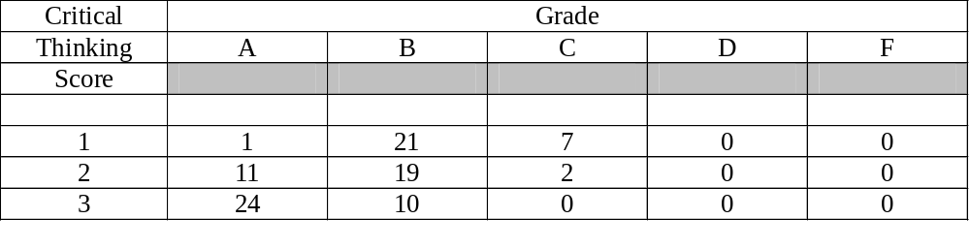
Page 11

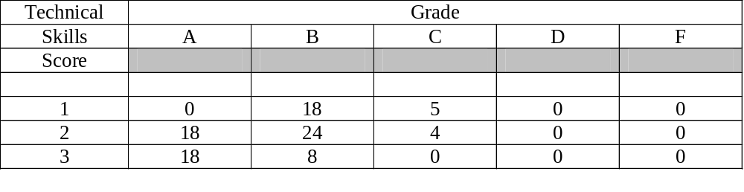
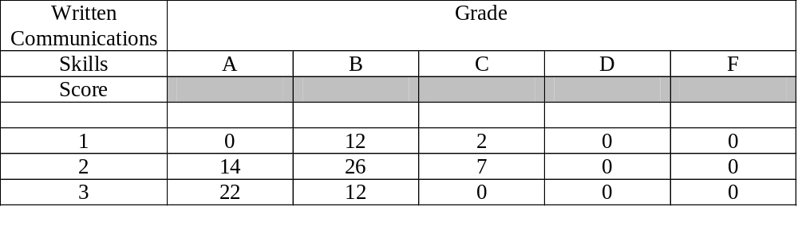
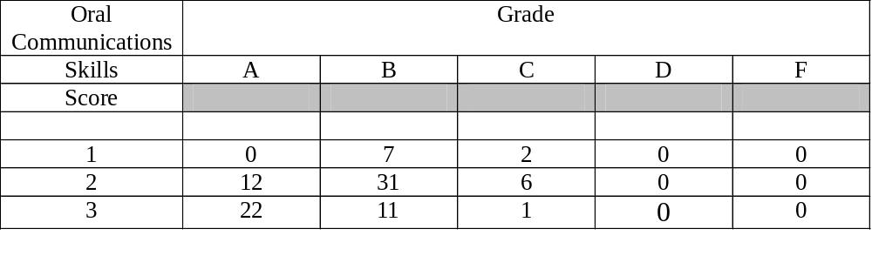
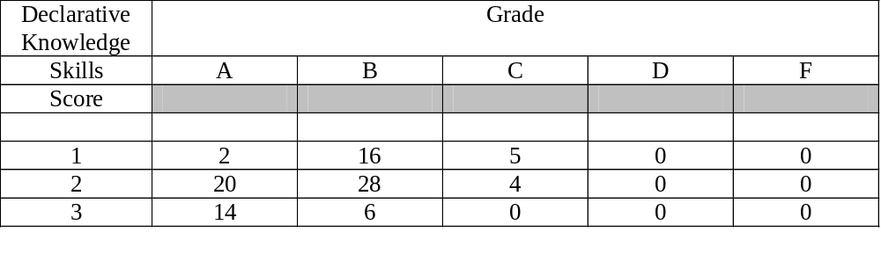________________________________________________________________________________________________________________________________________________________________________________________________________________________

Page 12

Spring 2010 Semester MAN 4720
Assessment Information for Economics Majors

Spring 2010 Correlations for Economics Majors

CT TS WC OC DK
TS .63
WC .64 .53
OC .14 .57 .17
DK -.08 .22 .32 .80
Grade .53 .37 .39 .59 .56

Spring 2010 Frequencies for Economics Majors

CT Frequency__% TS Frequency__% WC Frequency__%
1 1 7 1 2 15 1 1 8
2 8 62 2 6 46 2 9 69
3 4 31 3 5 39 3 3 23

OC Score Frequency__% DK Score Frequency__%
1 3 23 1 3 23
2 6 46 2 5 39
3 4 31 3 5 39

Spring 2010 Economics Majors

CHI-SQUARE BY MEASURE and FINAL GRADE

Critical | Grade
Thinking | A | B | C | D | F
Score
1 | 0 | 0 | 1 | 0 | 0
2 | 2 | 4 | 2 | 0 | 0
3 | 3 | 1 | 0 | 0 | 0

Page 13

Technical | Grade
Skills | A | B | C | D | F
Score
1 | 1 | 0 | 1 | 0 | 0
2 | 2 | 2 | 2 | 0 | 0
3 | 2 | 3 | 0 | 0 | 0

Written Communications | Grade
Skills | A | B | C | D | F
Score
1 | 0 | 0 | 1 | 0 | 0
2 | 3 | 5 | 1 | 0 | 0
3 | 2 | 0 | 1 | 0 | 0

Oral Communications | Grade
Skills | A | B | C | D | F
Score
1 | 1 | 0 | 2 | 0 | 0
2 | 2 | 3 | 1 | 0 | 0
3 | 2 | 2 | 0 | 0 | 0

Declarative Knowledge | Grade
Skills | A | B | C | D | F
Score
1 | 1 | 1 | 1 | 0 | 0
2 | 1 | 2 | 2 | 0 | 0
3 | 3 | 2 | 0 | 0 | 0

Page 14
Fall 2009 Semester MAN 4720
Assessment Information for Economics Majors

Fall 2009 Correlations for Economics Majors

CT TS WC OC DK
TS .71
WC .00 .29
OC .56 .79 .09
DK .00 .23 .03 .29
Grade .33 .15 -.02 .06 .44

Fall 2009 Frequencies for Economics Majors

CT Frequency__% TS Frequency__% WC Frequency__%
1 2 17 1 3 25 1 2 17
2 9 75 2 7 58 2 9 75
3 1 8 3 2 17 3 1 8

OC Score Frequency__% DK Score Frequency__%
1 0 0 1 3 25
2 8 80 2 6 50
3 2 20 3 3 25

Fall 2009 Economics Majors

CHI-SQUARE BY MEASURE and FINAL GRADE

Critical | Grade
Thinking | A | B | C | D | F
Score
1 | 0 | 1 | 1 | 0 | 0
2 | 3 | 5 | 1 | 0 | 0
3 | 1 | 0 | 0 | 0 | 0

Page 15
Technical | Grade
Skills | A | B | C | D | F
Score
1 | 0 | 2 | 1 | 0 | 0
2 | 3 | 3 | 1 | 0 | 0
3 | 1 | 1 | 0 | 0 | 0

Written Communications | Grade
Skills | A | B | C | D | F
Score
1 | 1 | 1 | 0 | 0 | 0
2 | 2 | 5 | 2 | 0 | 0
3 | 1 | 0 | 0 | 0 | 0

Oral Communications | Grade
Skills | A | B | C | D | F
Score
1 | 0 | 0 | 0 | 0 | 0
2 | 3 | 4 | 1 | 0 | 0
3 | 1 | 1 | 0 | 0 | 0

Declarative Knowledge | Grade
Skills | A | B | C | D | F
Score
1 | 0 | 1 | 2 | 0 | 0
2 | 2 | 4 | 0 | 0 | 0
3 | 2 | 1 | 0 | 0 | 0

Page 16

Summer 2009 Semester MAN 4720
Assessment Information for Economics Majors

Summer 2009 Correlations for Economics Majors

CT TS WC OC DK
TS .56
WC .56 .69
OC .15 .53 .87
DK .00 .79 .40 .42
Grade .69 .86 .59 .24 .68

Summer 2009 Frequencies for Economics Majors

CT Frequency__% TS Frequency__% WC Frequency__%
1 1 17 1 3 50 1 3 50
2 1 17 2 1 17 2 1 17
3 4 67 3 2 33 3 2 33

OC Score Frequency__% DK Score Frequency__%
1 2 40 1 1 17
2 2 40 2 3 50
3 1 20 3 2 33

Page 17
Summer 2009 Economics Majors

CHI-SQUARE BY MEASURE and FINAL GRADE

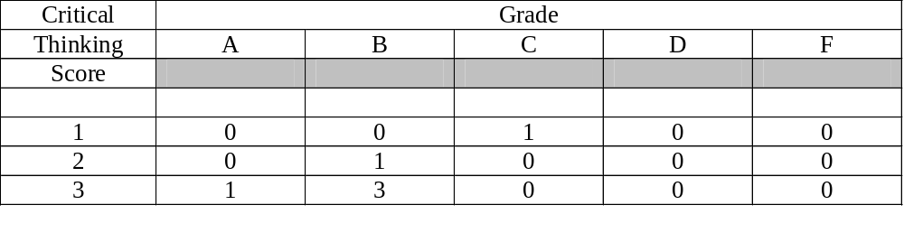
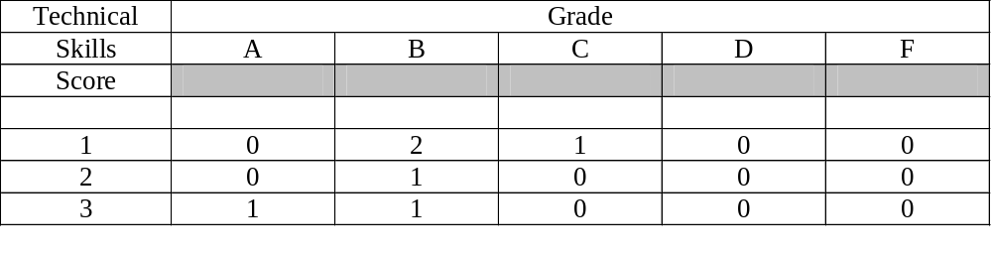
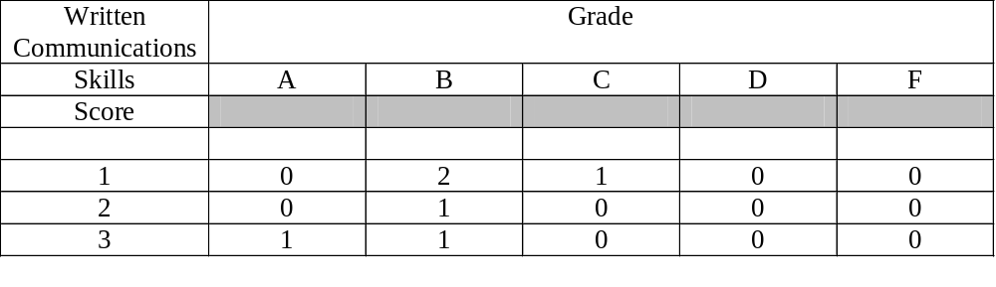

Page 18
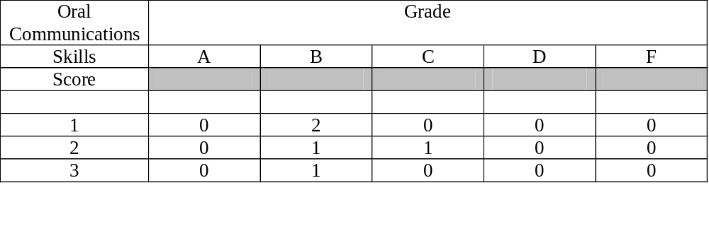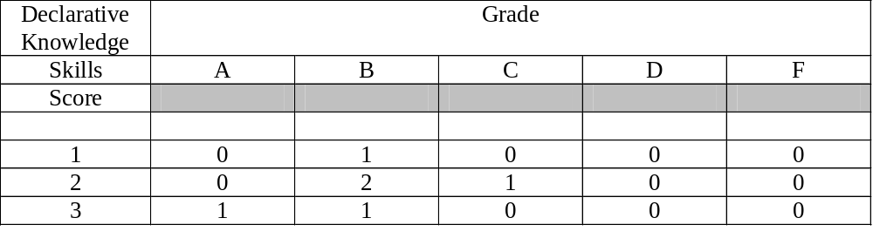
_______________________________________________________________________________________________________________________

Spring 2009
Not enough students for a report on Economics majors.

________________________________________________________________________________________________________________________________________________________________________________________________________________________

Page 19
Spring 2010 Assessment Information
for Finance Majors

Spring 2010 Correlations for Finance Majors

CT TS WC OC DK
TS .63
WC .62 .61
OC .24 .17 .15
DK .48 .39 .36 .22
Grade .67 .42 .47 .45 .55

Spring 2010 Frequencies for Finance Majors

CT Frequency__% TS Frequency__% WC Frequency__%
1 14 24 1 14 24 1 12 20
2 25 42 2 27 46 2 32 54
3 20 34 3 18 30 3 15 25

OC Score Frequency__% DK Score Frequency__%
1 16 27 1 11 19
2 30 51 2 31 52
3 13 22 3 17 29

Spring 2010 Finance Majors
CHI-SQUARE BY MEASURE and FINAL GRADE

Critical | Grade
Thinking | A | B | C | D | F
Score
1 | 0 | 2 | 8 | 3 | 1
2 | 5 | 15 | 4 | 1 | 0
3 | 12 | 6 | 2 | 0 | 0

Page 20
Technical | Grade
Skills | A | B | C | D | F
Score
1 | 0 | 5 | 5 | 3 | 1
2 | 9 | 11 | 7 | 0 | 0
3 | 8 | 7 | 2 | 1 | 0

Written Communications | Grade
Skills | A | B | C | D | F
Score
1 | 0 | 3 | 5 | 3 | 1
2 | 10 | 15 | 7 | 0 | 0
3 | 7 | 5 | 2 | 1 | 0

Oral Communications | Grade
Skills | A | B | C | D | F
Score
1 | 2 | 6 | 4 | 3 | 1
2 | 9 | 12 | 8 | 1 | 0
3 | 6 | 5 | 2 | 0 | 0

Declarative Knowledge | Grade
Skills | A | B | C | D | F
Score
1 | 1 | 2 | 6 | 2 | 0
2 | 4 | 17 | 8 | 1 | 1
3 | 12 | 4 | 0 | 1 | 0

Page 21
Fall 2009 Assessment Information
for Finance Majors

Fall 2009 Correlations for Finance Majors

CT TS WC OC DK
TS .69
WC .65 .70
OC .35 .27 .20
DK .35 .29 .21 .19
Grade .63 .46 .34 .28 .36

Fall 2009 Frequencies for Finance Majors

CT Frequency__% TS Frequency__% WC Frequency__%
1 11 17 1 8 12 1 7 11
2 31 48 2 38 59 2 34 52
3 23 35 3 19 29 3 24 37

OC Score Frequency__% DK Score Frequency__%
1 2 3 1 14 21
2 38 60 2 29 44
3 23 37 3 23 35

Fall 2009 Finance Majors
CHI-SQUARE BY MEASURE and FINAL GRADE

Declarative Knowledge | Grade
Skills | A | B | C | D | F
Score
1 | 0 | 1 | 2 | 0 | 0
2 | 2 | 4 | 0 | 0 | 0
3 | 2 | 1 | 0 | 0 | 0

Page 22
Technical | Grade
Skills | A | B | C | D | F
Score
1 | 1 | 3 | 3 | 1 | 0
2 | 10 | 21 | 6 | 1 | 0
3 | 13 | 5 | 1 | 0 | 0

Written Communications | Grade
Skills | A | B | C | D | F
Score
1 | 1 | 3 | 3 | 0 | 0
2 | 9 | 17 | 6 | 2 | 0
3 | 14 | 9 | 1 | 0 | 0

Oral Communications | Grade
Skills | A | B | C | D | F
Score
1 | 0 | 2 | 0 | 0 | 0
2 | 11 | 20 | 5 | 2 | 0
3 | 12 | 8 | 3 | 0 | 0

Declarative Knowledge | Grade
Skills | A | B | C | D | F
Score
1 | 2 | 5 | 7 | 0 | 0
2 | 6 | 21 | 1 | 1 | 0
3 | 16 | 4 | 2 | 1 | 0

Page 23
Summer 2009 Assessment Information
for Finance Majors

Summer 2009 Correlations for Finance Majors

CT TS WC OC DK
TS .73
WC .71 .67
OC .30 .19 .48
DK .41 .33 .36 .22
Grade .67 .65 .79 .62 .55

Summer 2009 Frequencies for Finance Majors

CT Frequency__% TS Frequency__% WC Frequency__%
1 7 19 1 8 22 1 8 22
2 17 46 2 20 54 2 21 57
3 13 35 3 9 24 3 8 22

OC Score Frequency__% DK Score Frequency__%
1 7 21 1 13 35
2 19 56 2 19 51
3 8 24 3 5 14

__________________________________________________________________________________________________________

Summer 2009 Finance Majors

CHI-SQUARE BY MEASURE and FINAL GRADE
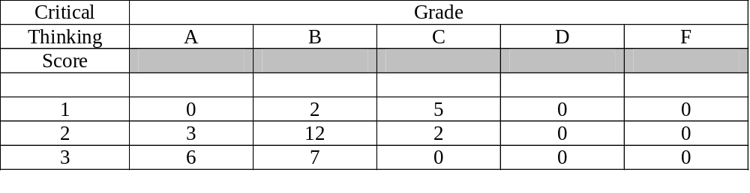 Page 24
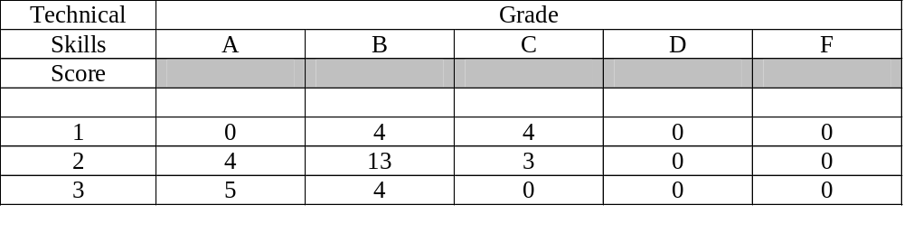
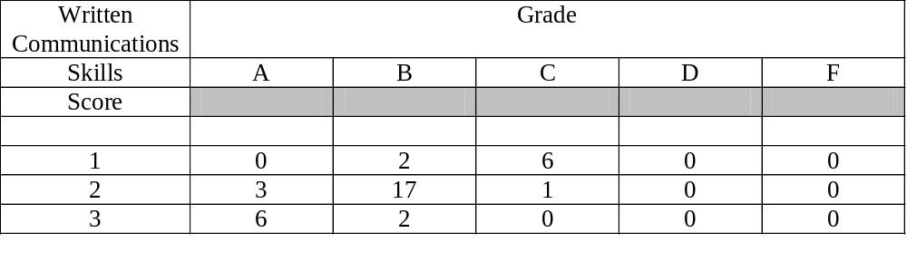
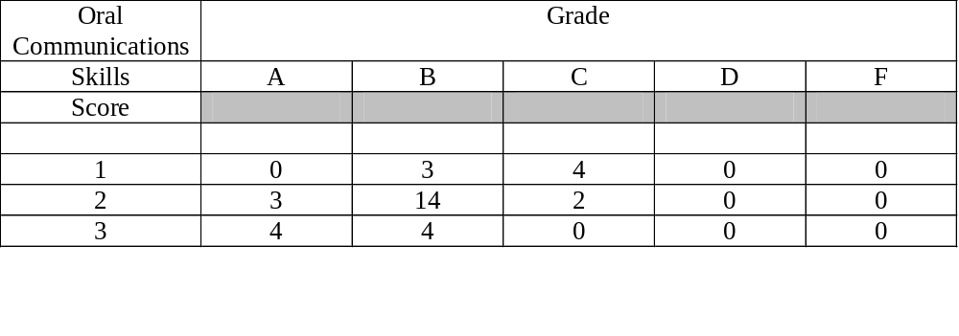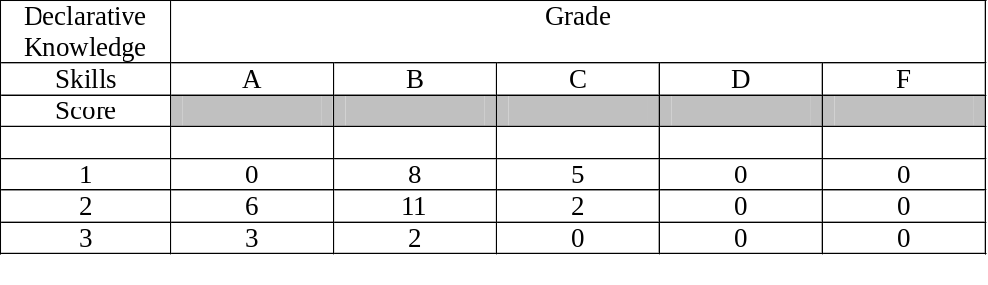___________________________________________________________________________________________________________

Page 25
Spring 2009Assessment Information
for Finance Majors

Spring 2009 Correlations For Finance Majors

CT TS WC OC DK
TS .68
WC .51 .59
OC .27 .19 .28
DK .25 .32 .57 .24
Grade .40 .48 .62 .36 .66

Spring 2009 Frequencies for Finance Majors

CT Frequency__% TS Frequency__% WC Frequency__%
1 21 28 1 19 26 1 10 10
2 31 42 2 28 38 2 41 56
3 22 30 3 27 37 3 22 30

OC Score Frequency__% DK Score Frequency__%
1 7 10 1 21 29
2 37 55 2 38 52
3 23 34 3 14 19

Spring 2009 Finance Majors
CHI-SQUARE BY MEASURE and FINAL GRADE

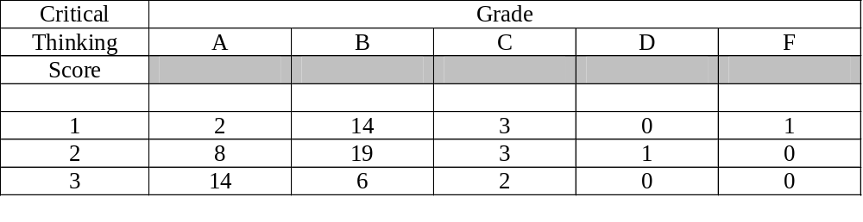
Page 26
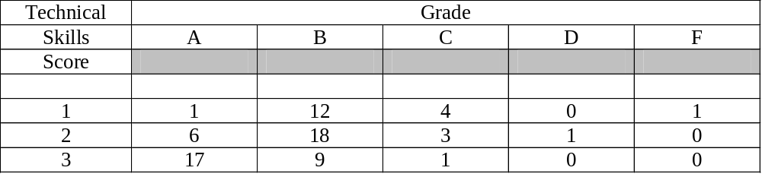
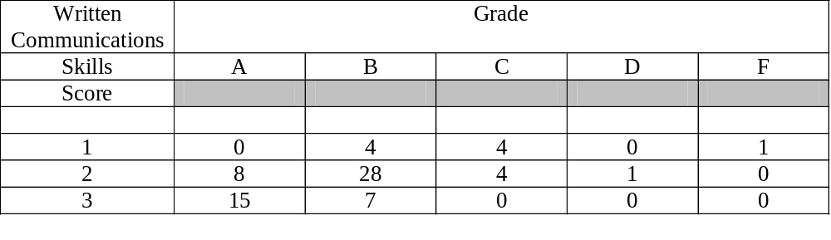
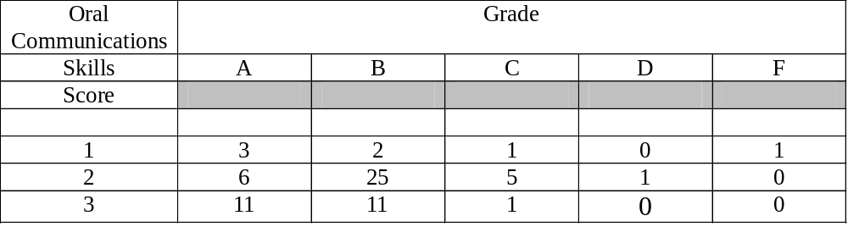
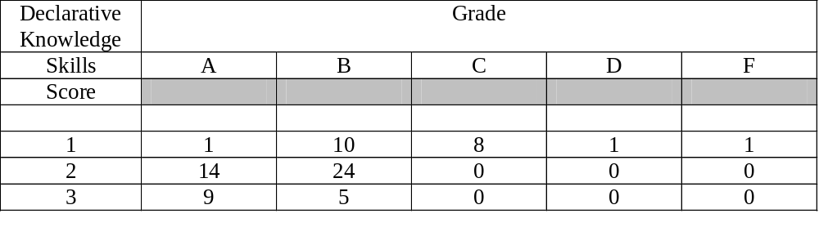_________________________________________________________________________________________________________________________________________________________________

Page 27
Spring 2010Assessment Information
for Hospitality and Tourism Majors

Spring 2010 Correlations For Hospitality Majors

CT TS WC OC DK
TS -.04
WC .50 -.30
OC -.39 .65 -.57
DK .04 -.65 .03 -.65
Grade -.74 .63 -.71 .89 -.67

The limited sample size may have distorted the correlations.

Spring 2010 Frequencies for Hospitality Majors

CT Frequency__% TS Frequency__% WC Frequency__%
1 2 25 1 2 25 1 3 38
2 5 63 2 5 63 2 3 38
3 1 12 3 1 12 3 2 25

OC Score Frequency__% DK Score Frequency__%
1 2 25 1 1 12
2 4 63 2 5 63
3 1 12 3 2 25

Spring 2010
CHI-SQUARE BY MEASURE and FINAL GRADE
For Hospitality and Tourism Majors

Critical | Grade
Thinking | A | B | C | D | F
Score
1 | 0 | 2 | 0 | 0 | 0
2 | 2 | 1 | 2 | 0 | 0
3 | 0 | 0 | 2 | 1 | 0

Page 28
Technical | Grade
Skills | A | B | C | D | F
Score
1 | 0 | 1 | 0 | 1 | 0
2 | 1 | 2 | 2 | 0 | 0
3 | 1 | 0 | 0 | 0 | 0

Written Communications | Grade
Skills | A | B | C | D | F
Score
1 | 1 | 2 | 0 | 0 | 0
2 | 1 | 1 | 1 | 0 | 0
3 | 0 | 0 | 1 | 1 | 0

Oral Communications | Grade
Skills | A | B | C | D | F
Score
1 | 0 | 0 | 1 | 1 | 0
2 | 1 | 3 | 1 | 0 | 0
3 | 1 | 0 | 0 | 0 | 0

Declarative Knowledge | Grade
Skills | A | B | C | D | F
Score
1 | 1 | 0 | 0 | 0 | 0
2 | 1 | 2 | 2 | 0 | 0
3 | 0 | 1 | 0 | 1 | 0

Page 29

Fall 2009Assessment Information
for Hospitality and Tourism Majors

Fall 2009 Correlations For Hospitality Majors

Not enough valid cases to report correlations.

Fall 2009 Frequencies for Hospitality Majors

CT Frequency__% TS Frequency__% WC Frequency__%
1 0 0 1 0 0 1 0 0
2 3 100 2 2 67 2 3 100
3 0 0 3 1 33 3 0 0

OC Score Frequency__% DK Score Frequency__%
1 0 0 1 1 25
2 2 50 2 3 75
3 2 50 3 0 0

Fall 2009
CHI-SQUARE BY MEASURE and FINAL GRADE
For Hospitality and Tourism Majors

Critical | Grade
Thinking | A | B | C | D | F
Score
1 | 0 | 0 | 0 | 0 | 0
2 | 0 | 1 | 2 | 0 | 0
3 | 0 | 0 | 0 | 0 | 0

Page 30
Technical | Grade
Skills | A | B | C | D | F
Score
1 | 0 | 0 | 0 | 0 | 0
2 | 0 | 0 | 2 | 0 | 0
3 | 0 | 1 | 0 | 0 | 0

Written Communications | Grade
Skills | A | B | C | D | F
Score
1 | 0 | 0 | 0 | 0 | 0
2 | 0 | 1 | 2 | 0 | 0
3 | 0 | 0 | 0 | 0 | 0

Oral Communications | Grade
Skills | A | B | C | D | F
Score
1 | 0 | 0 | 0 | 0 | 0
2 | 0 | 1 | 1 | 0 | 0
3 | 0 | 0 | 2 | 0 | 0

Declarative Knowledge | Grade
Skills | A | B | C | D | F
Score
1 | 0 | 0 | 1 | 0 | 0
2 | 0 | 1 | 2 | 0 | 0
3 | 0 | 0 | 0 | 0 | 0

________________________________________________________________________________________________________________________________________________

Page 31
SUMMER 2009Assessment Information
for Hospitality and Tourism Majors

Summer 2009 Correlations For Hospitality Majors

CT TS WC OC DK
TS .54
WC .29 .54
OC .42 .77 .00
DK .24 .45 .25 .00
Grade .74 .90 .71 .57 .38

Summer 2009 Frequencies for Hospitality Majors

CT Frequency__% TS Frequency__% WC Frequency__%
1 2 30 1 1 14 1 2 29
2 4 57 2 5 71 2 4 57
3 1 14 3 1 14 3 1 14

OC Score Frequency__% DK Score Frequency__%
1 1 17 1 3 43
2 4 67 2 4 67
3 1 17 3 0 0

Summer 2009
CHI-SQUARE BY MEASURE and FINAL GRADE
For Hospitality and Tourism Majors

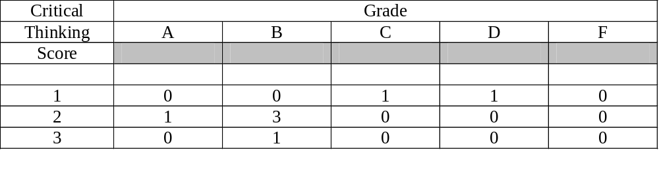
Page 32
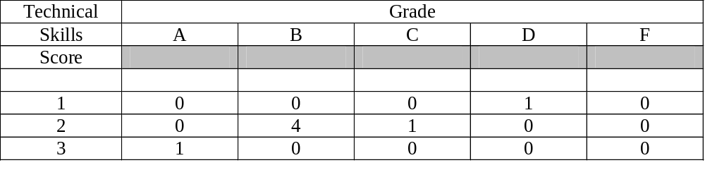

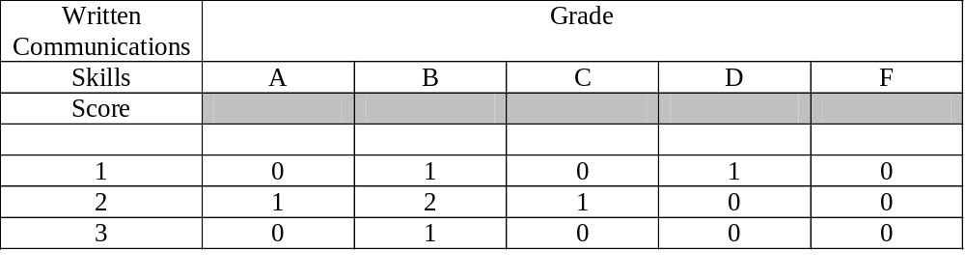
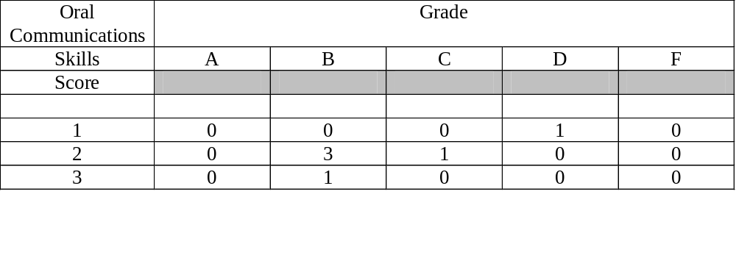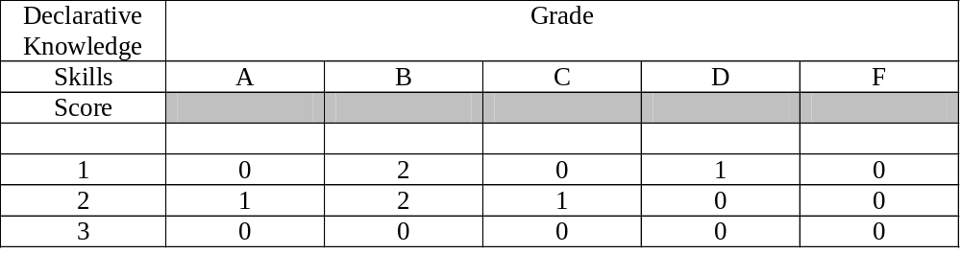________________________________________________________________________________________________________________________________________________

Page 33
Spring 2009Assessment Information for
Hospitality and Tourism Majors

Spring 2009 Correlations For Hospitality Majors

CT TS WC OC DK
TS .76
WC .60 .61
OC .06 - .05 .14
DK .34 .11 .33 .31
Grade .67 .70 .52 .44 .42

Spring 2009 Frequencies for Hospitality Majors

CT Frequency__% TS Frequency__% WC Frequency__%
1 7 47 1 4 27 1 4 27
2 5 33 2 8 53 2 8 53
3 3 22 3 3 20 3 3 20

OC Score Frequency__% DK Score Frequency__%
1 4 29 1 4 27
2 8 57 2 10 67
3 2 14 3 1 7

Spring 2009
CHI-SQUARE BY MEASURE and FINAL GRADE
For Hospitality and Tourism Majors

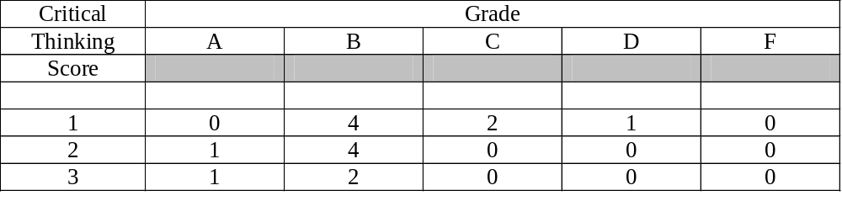

Page 34
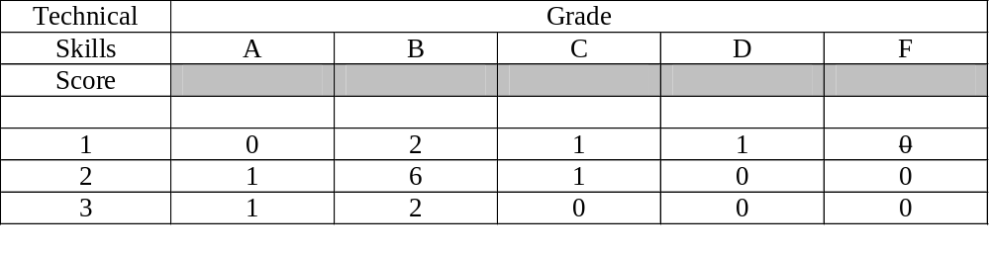
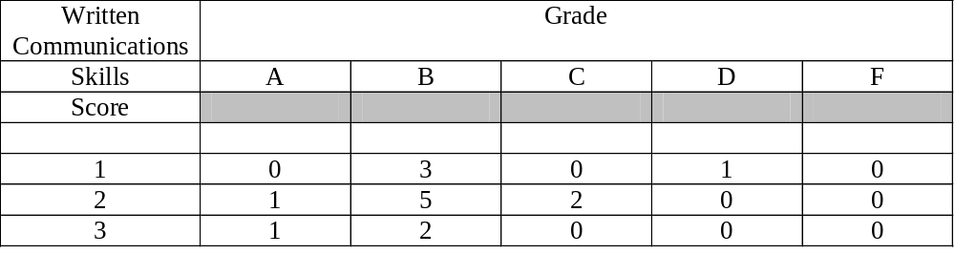
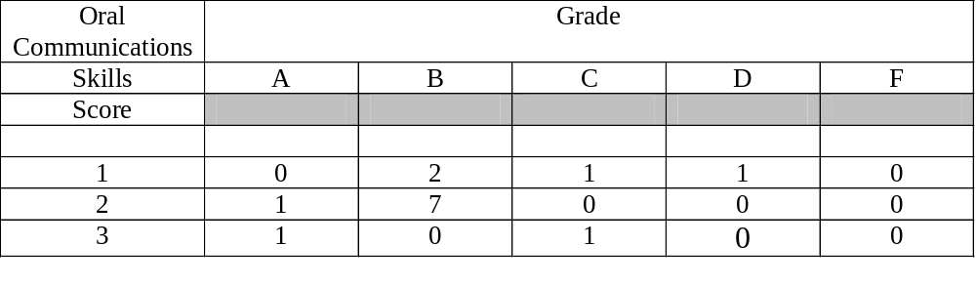
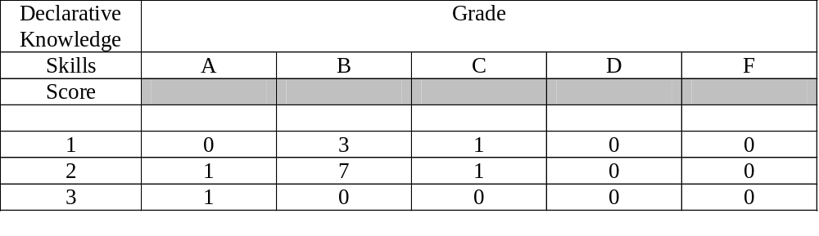________________________________________________________________________________________________________________________________________________
________________________________________________________________________

Page 35
Spring 2019Assessment Information
for Real Estate Majors

No analysis was performed because there was only one student in this major.

Fall 2009 Assessment Information
for Real Estate Majors

Fall 2009 Correlations for Real Estate Majors

CT TS WC OC DK
TS .79
WC .06 .40
OC .38 .79 .38
DK .20 .42 .87 .53
Grade .68 .67 .64 .52 .84

Fall 2009 Frequencies for Real Estate Majors

CT Frequency__% TS Frequency__% WC Frequency__%
1 1 20 1 1 20 1 1 20
2 1 20 2 3 60 2 1 20
3 3 60 3 1 20 3 3 60

OC Score Frequency__% DK Score Frequency__%
1 0 0 1 1 20
2 4 80 2 2 40
3 1 20 3 2 40

Page 36
Fall 2009
CHI-SQUARE BY MEASURE and FINAL GRADE
For Real Estate Majors

Critical | Grade
Thinking | A | B | C | D | F
Score
1 | 0 | 1 | 0 | 0 | 0
2 | 0 | 1 | 0 | 0 | 0
3 | 2 | 1 | 0 | 0 | 0

Technical | Grade
Skills | A | B | C | D | F
Score
1 | 0 | 1 | 0 | 0 | 0
2 | 1 | 2 | 0 | 0 | 0
3 | 1 | 0 | 0 | 0 | 0

Written Communications | Grade
Skills | A | B | C | D | F
Score
1 | 0 | 1 | 0 | 0 | 0
2 | 0 | 1 | 0 | 0 | 0
3 | 2 | 1 | 0 | 0 | 0

Oral Communications | Grade
Skills | A | B | C | D | F
Score
1 | 0 | 0 | 0 | 0 | 0
2 | 1 | 3 | 0 | 0 | 0
3 | 1 | 0 | 0 | 0 | 0

Page 37
Declarative Knowledge | Grade
Skills | A | B | C | D | F
Score
1 | 0 | 1 | 0 | 0 | 0
2 | 0 | 2 | 0 | 0 | 0
3 | 2 | 0 | 0 | 0 | 0

___________________________________________________________________________________________________________

Summer 2009
Assessment Information for Real Estate Majors
in MAN 4720 for the Summer 2009 Semester

Not enough students for an analysis.

________________________________________________________________________________________________________________________________________________

Spring 2009 Assessment Information
for Real Estate Majors

Spring 2009 Correlations for Real Estate Majors

CT TS WC OC DK
TS .88
WC -.10 -.41
OC .00 .00 .64
DK -.28 -.56 .91 .35
Grade -.27 -.70 .80 .20 .80

The low number of students (5) may explain the negative correlations.

Page 38

Spring 2009 Frequencies for Real Estate Majors

CT Frequency__% TS Frequency__% WC Frequency__%
1 3 50 1 0 0 1 0 0
2 2 33 2 5 83 2 4 67
3 1 17 3 1 17 3 2 33

OC Score Frequency__% DK Score Frequency__%
1 1 20 1 3 50
2 3 60 2 1 17
3 1 20 3 2 33

Spring 2009
CHI-SQUARE BY MEASURE and FINAL GRADE
For Real Estate Majors

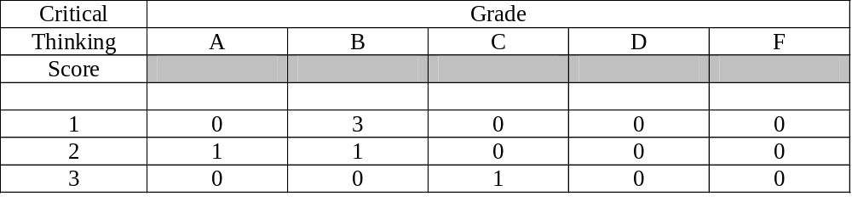
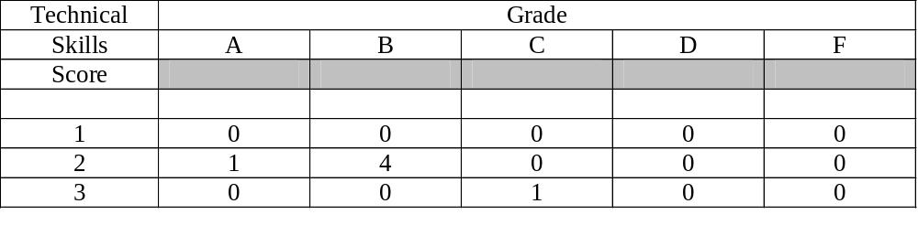

Page 39

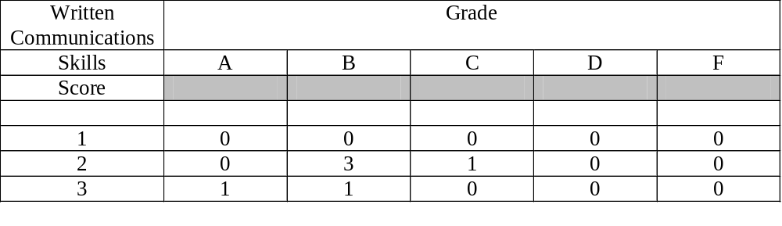
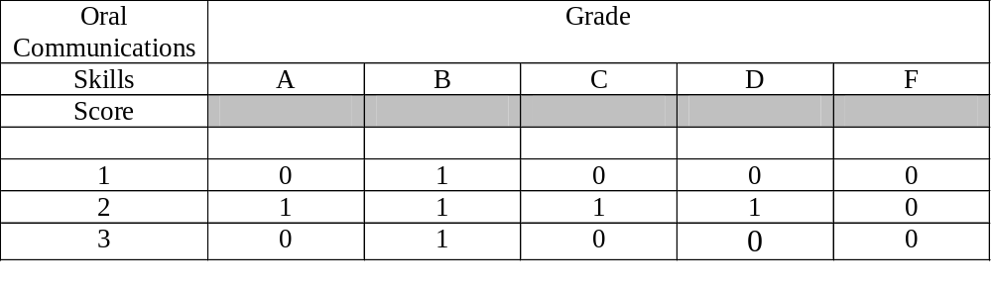 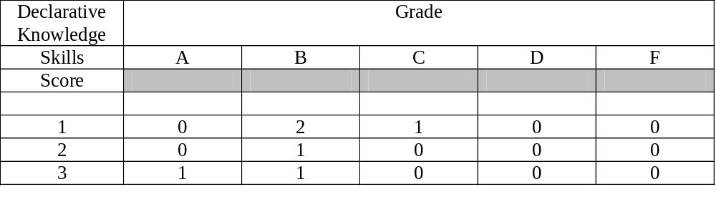___________________________________________________________________________________________________________
______________________________________________________

Page 40
Spring 2010 Assessment Information
for MIS Majors

Spring 2010 Correlations For MIS Majors

CT TS WC OC DK
TS .77
WC .43 .46
OC .08 -.01 -.07
DK .18 .32 .00 .00
Grade .37 .46 .24 .13 .71

Spring 2010 Frequencies for MIS Majors

CT Frequency__% TS Frequency__% WC Frequency___%
1 4 22 1 6 33 1 3 17
2 8 44 2 10 56 2 10 56
3 6 33 3 2 11 3 5 28

OC Score Frequency__% DK Score Frequency__%
1 6 33 1 6 33
2 11 61 2 6 33
3 1 6 3 6 33

Spring2009
CHI-SQUARE BY MEASURE and FINAL GRADE
For MIS Majors

Critical | Grade
Thinking | A | B | C | D | F
Score
1 | 0 | 1 | 3 | 0 | 0
2 | 1 | 4 | 3 | 0 | 0
3 | 2 | 3 | 1 | 0 | 0

Page 41
Technical | Grade
Skills | A | B | C | D | F
Score
1 | 0 | 2 | 4 | 0 | 0
2 | 1 | 6 | 3 | 0 | 0
3 | 2 | 0 | 0 | 0 | 0

Written Communications | Grade
Skills | A | B | C | D | F
Score
1 | 0 | 2 | 1 | 0 | 0
2 | 1 | 4 | 5 | 0 | 0
3 | 2 | 2 | 1 | 0 | 0

Oral Communications | Grade
Skills | A | B | C | D | F
Score
1 | 1 | 3 | 2 | 0 | 0
2 | 2 | 4 | 5 | 0 | 0
3 | 0 | 1 | 0 | 0 | 0

Declarative Knowledge | Grade
Skills | A | B | C | D | F
Score
1 | 0 | 1 | 5 | 0 | 0
2 | 1 | 3 | 2 | 0 | 0
3 | 2 | 4 | 0 | 0 | 0

___________________________________________________________________________________________________________

Page 42
Fall 2009 Assessment Information
for MIS Majors

Fall 2009 Correlations For MIS Majors

CT TS WC OC DK
TS .65
WC .55 .65
OC .23 -.10 .23
DK .21 .18 .03 .03
Grade .78 .63 .51 .28 .48

Fall 2009 Frequencies for MIS Majors

CT Frequency__% TS Frequency__% WC Frequency___%
1 1 6 1 2 11 1 1 6
2 12 67 2 10 56 2 13 72
3 5 28 3 6 33 3 4 22

OC Score Frequency__% DK Score Frequency__%
1 0 0 1 5 28
2 15 88 2 10 56
3 2 12 3 3 17

Fall 2009
CHI-SQUARE BY MEASURE and FINAL GRADE
For MIS Majors

Critical | Grade
Thinking | A | B | C | D | F
Score
1 | 0 | 0 | 1 | 0 | 0
2 | 1 | 9 | 2 | 0 | 0
3 | 3 | 1 | 1 | 0 | 0

Page 43
Technical | Grade
Skills | A | B | C | D | F
Score
1 | 0 | 2 | 0 | 0 | 0
2 | 1 | 6 | 3 | 0 | 0
3 | 3 | 2 | 1 | 0 | 0

Written Communications | Grade
Skills | A | B | C | D | F
Score
1 | 1 | 0 | 0 | 0 | 0
2 | 0 | 9 | 4 | 0 | 0
3 | 3 | 1 | 0 | 0 | 0

Oral Communications | Grade
Skills | A | B | C | D | F
Score
1 | 0 | 0 | 0 | 0 | 0
2 | 3 | 9 | 3 | 0 | 0
3 | 1 | 1 | 0 | 0 | 0

Declarative Knowledge | Grade
Skills | A | B | C | D | F
Score
1 | 0 | 1 | 4 | 0 | 0
2 | 3 | 7 | 0 | 0 | 0
3 | 1 | 2 | 0 | 0 | 0

___________________________________________________________________________________________________________

Page 44
Summer 2009 Assessment Information
for MIS Majors

Summer 2009 Correlations For MIS Majors

CT TS WC OC DK
TS .77
WC .64 .37
OC .67 .55 .24
DK -.15 -.49 .27 .18
Grade .33 .20 .73 .40 .65

Summer 2009 Frequencies for MIS Majors

CT Frequency__% TS Frequency__% WC Frequency__%
1 3 27 1 2 18 1 1 9
2 4 36 2 6 54 2 7 64
3 4 36 3 3 27 3 3 27

OC Score Frequency__% DK Score Frequency__%
1 1 11 1 5 46
2 5 56 2 5 46
3 3 33 3 1 9

Summer 2009
CHI-SQUARE BY MEASURE and FINAL GRADE
For MIS Majors

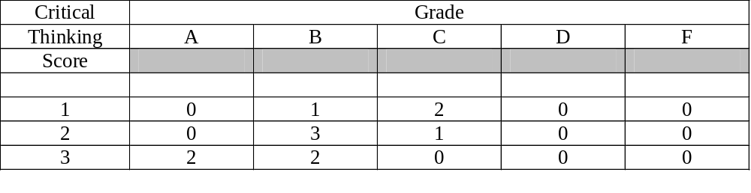

Page 45
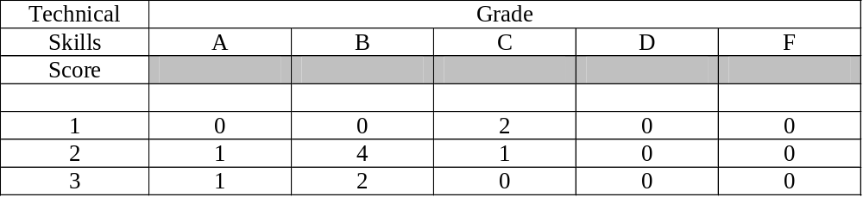
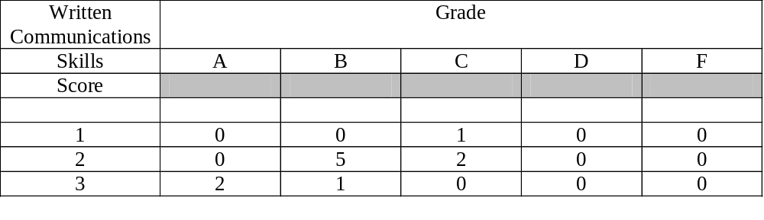
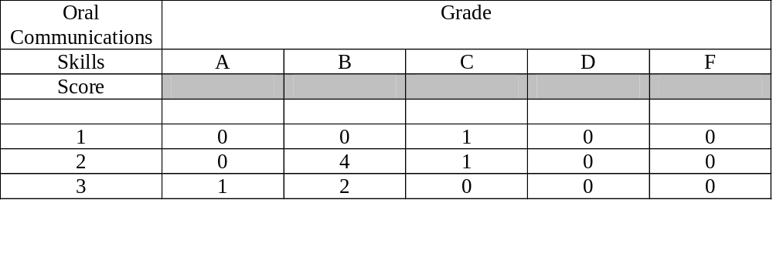

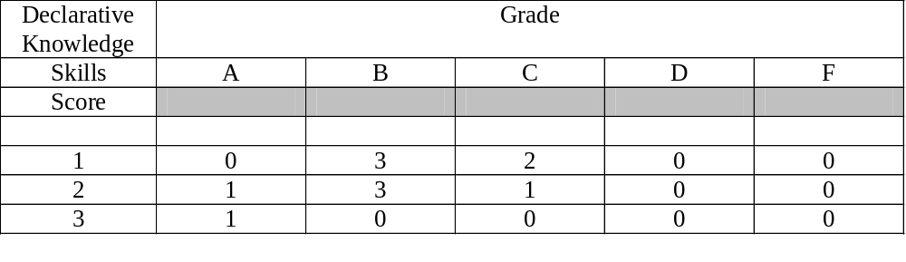
________________________________________________________________________________________________________________________________________________

Page 46
Spring 2009 Assessment Information
for MIS Majors

Spring 2009 Correlations For MIS Majors

CT TS WC OC DK
TS .70
WC .74 .76
OC .05 .41 .29
DK -.17 -.17 .08 - .32
Grade .43 .10 .44 .13 .21

Spring 2009 Frequencies for MIS Majors

CT Frequency__% TS Frequency__% WC Frequency__%
1 9 50 1 6 33 1 4 22
2 7 39 2 8 44 2 10 56
3 2 11 3 4 22 3 4 22

OC Score Frequency__% DK Score Frequency__%
1 3 18 1 8 44
2 10 59 2 6 33
3 4 24 3 4 22

Spring 2009
CHI-SQUARE BY MEASURE and FINAL GRADE
For MIS Majors

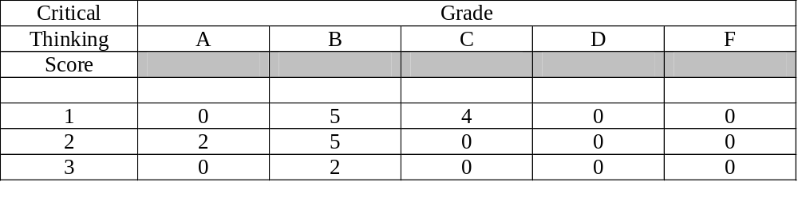page 47 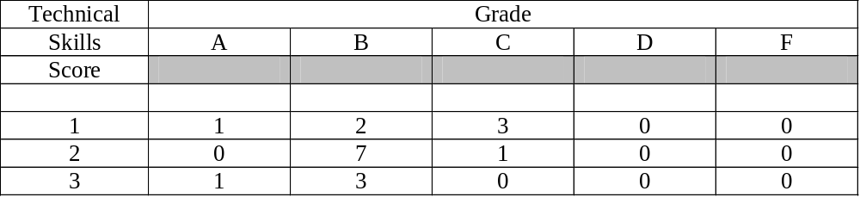
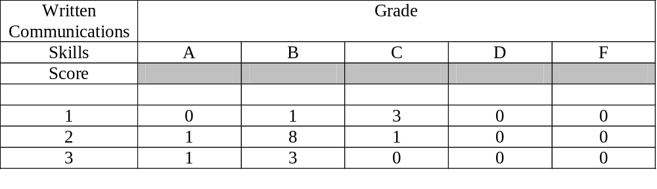
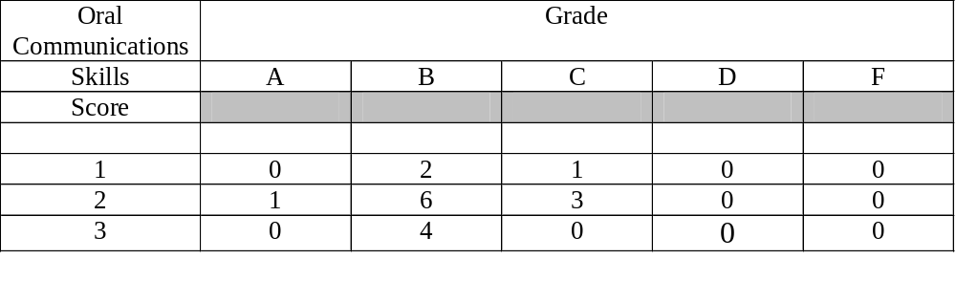 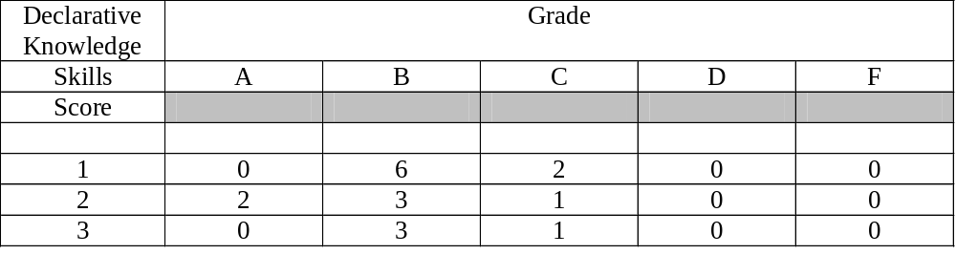___________________________________________________________________________________________________________
______________________________________________________

Page 48
Spring 2010Assessment Information
for International Business Majors

Spring 2010 Correlations for IB Majors

CT TS WC OC DK
TS .58
WC .51 .44
OC .31 .32 .20
DK .42 .17 .22 .22
Grade .38 .36 .28 .53 .47

Spring 2010 Frequencies for IB Majors

CT Frequency__% TS Frequency__% WC Frequency__%
1 5 14 1 10 29 1 12 34
2 22 63 2 16 46 2 17 49
3 8 23 3 9 26 3 6 17

OC Score Frequency__% DK Score Frequency__%
1 8 23 1 15 43
2 16 46 2 6 17
3 11 31 3 14 40

Spring 2010
CHI-SQUARE BY MEASURE and FINAL GRADE
For International Business Majors

Critical | Grade
Thinking | A | B | C | D | F
Score
1 | 0 | 1 | 3 | 0 | 1
2 | 4 | 12 | 6 | 0 | 0
3 | 4 | 3 | 0 | 1 | 0

Page 49
Technical | Grade
Skills | A | B | C | D | F
Score
1 | 2 | 3 | 4 | 0 | 1
2 | 3 | 7 | 5 | 1 | 0
3 | 3 | 6 | 1 | 0 | 0

Written Communications | Grade
Skills | A | B | C | D | F
Score
1 | 2 | 4 | 5 | 0 | 1
2 | 3 | 10 | 4 | 0 | 0
3 | 3 | 2 | 0 | 0 | 0

Oral Communications | Grade
Skills | A | B | C | D | F
Score
1 | 0 | 1 | 5 | 1 | 1
2 | 6 | 7 | 3 | 0 | 0
3 | 2 | 8 | 1 | 0 | 0

Declarative Knowledge | Grade
Skills | A | B | C | D | F
Score
1 | 1 | 6 | 7 | 0 | 1
2 | 2 | 3 | 1 | 0 | 0
3 | 5 | 7 | 1 | 1 | 0

________________________________________________________________________________________________________________________________________________

Page 50
Fall 2009Assessment Information
for International Business Majors

Fall 2009 Correlations for IB Majors

CT TS WC OC DK
TS .69
WC .50 .57
OC .31 .25 .21
DK .31 .33 .35 -.12
Grade .41 .49 .54 .34 .53

Fall 2009 Frequencies for IB Majors

CT Frequency__% TS Frequency__% WC Frequency__%
1 7 18 1 8 21 1 6 15
2 18 42 2 15 39 2 23 59
3 14 36 3 16 41 3 10 26

OC Score Frequency__% DK Score Frequency__%
1 2 5 1 7 17
2 24 63 2 25 41
3 12 32 3 9 22

Fall 2009
CHI-SQUARE BY MEASURE and FINAL GRADE
For International Business Majors

Critical | Grade
Thinking | A | B | C | D | F
Score
1 | 0 | 4 | 1 | 2 | 0
2 | 5 | 8 | 3 | 1 | 1
3 | 8 | 5 | 1 | 0 | 0

Page 51
Technical | Grade
Skills | A | B | C | D | F
Score
1 | 0 | 3 | 2 | 2 | 1
2 | 7 | 5 | 2 | 1 | 0
3 | 6 | 9 | 1 | 0 | 0

Written Communications | Grade
Skills | A | B | C | D | F
Score
1 | 0 | 2 | 1 | 3 | 0
2 | 6 | 13 | 3 | 0 | 1
3 | 7 | 2 | 1 | 0 | 0

Oral Communications | Grade
Skills | A | B | C | D | F
Score
1 | 0 | 1 | 0 | 1 | 0
2 | 6 | 12 | 3 | 2 | 1
3 | 5 | 5 | 2 | 0 | 0

Declarative Knowledge | Grade
Skills | A | B | C | D | F
Score
1 | 1 | 3 | 1 | 1 | 1
2 | 7 | 11 | 5 | 2 | 0
3 | 5 | 4 | 0 | 0 | 0

________________________________________________________________________________________________________________________________________________

Page 52
Summer 2009Assessment Information
for International Business Majors

Summer 2009 Correlations for IB Majors

CT TS WC OC DK
TS .50
WC .30 .66
OC .34 .50 .50
DK .20 .55 .36 .28
Grade .50 .60 .56 .49 .66

Summer 2009 Frequencies for IB Majors

CT Frequency__% TS Frequency__% WC Frequency__%
1 5 29 1 4 24 1 2 12
2 8 47 2 10 59 2 11 65
3 4 24 3 3 18 3 4 24

OC Score Frequency__% DK Score Frequency__%
1 4 27 1 9 53
2 5 33 2 7 41
3 6 40 3 1 6

Summer 2009
CHI-SQUARE BY MEASURE and FINAL GRADE
For International Business Majors

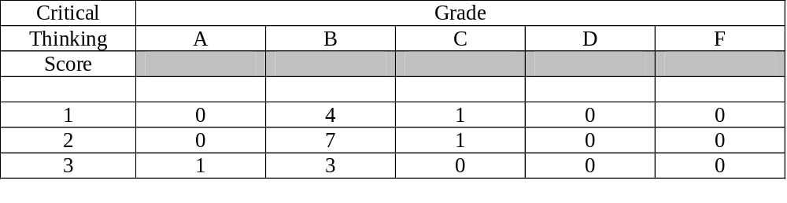

Page 53

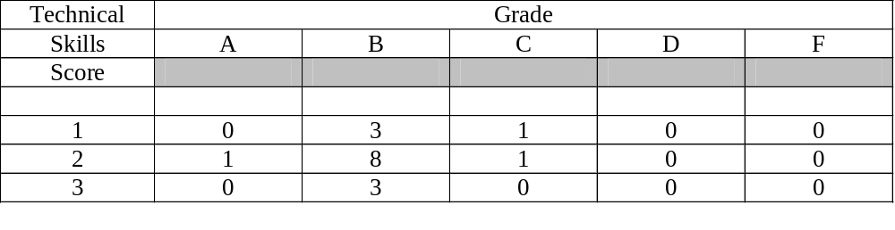
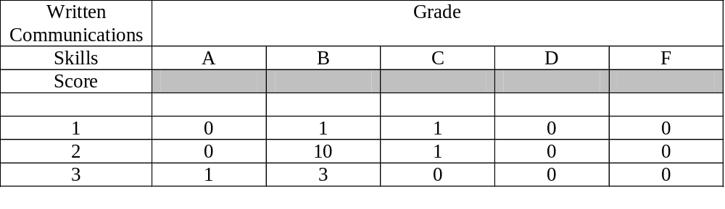 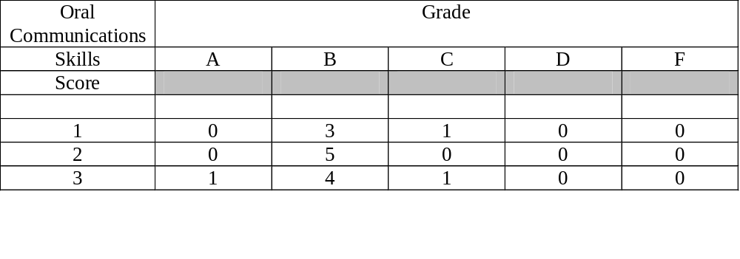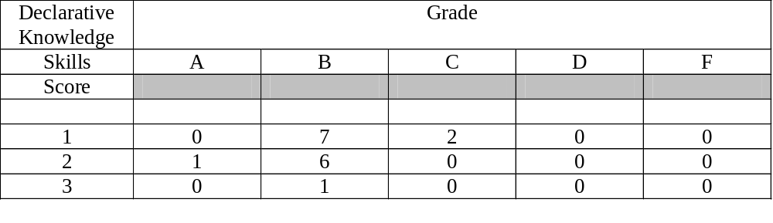________________________________________________________________________________________________________________________________________________

Page 54
Spring 2009 Assessment Information
for International Business Majors

Spring 2009 Correlations For IB Majors

CT TS WC OC DK
TS .94
WC .54 .44
OC .19 .04 .15
DK .54 .43 .34 - .05
Grade .76 .67 .41 .06 .53

Spring 2009 Frequencies for IB Majors

CT Frequency__% TS Frequency__% WC Frequency__%
1 11 39 1 10 36 1 9 32
2 8 29 2 11 39 2 14 50
3 9 32 3 7 25 3 5 18

OC Score Frequency__% DK Score Frequency__%
1 3 11 1 5 18
2 16 59 2 14 50
3 8 30 3 9 32

Spring 2009
CHI-SQUARE BY MEASURE and FINAL GRADE
For International Business Majors

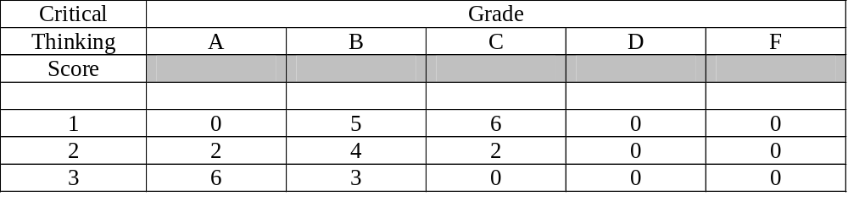

Page 55
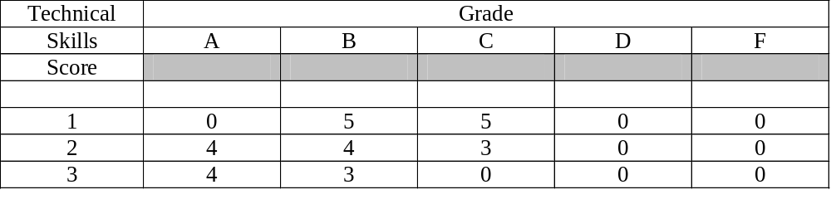
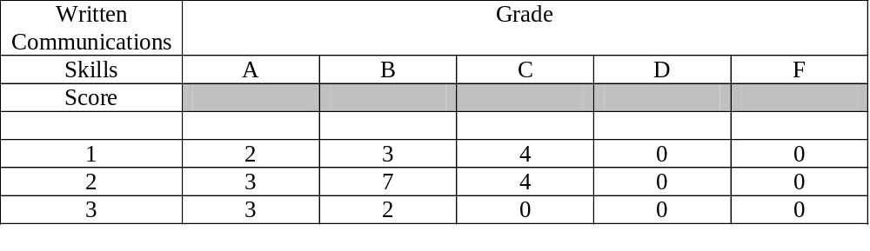
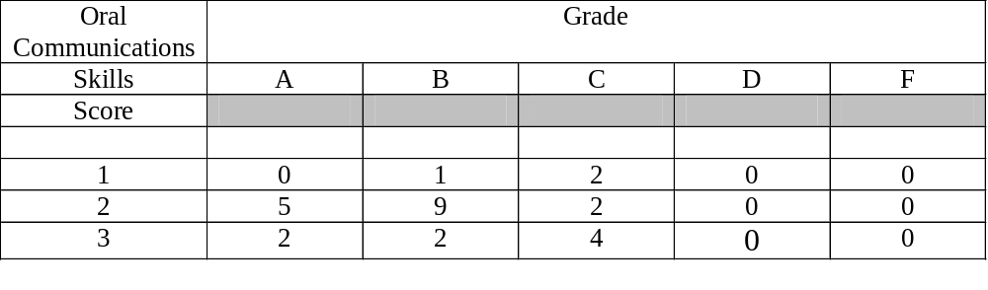 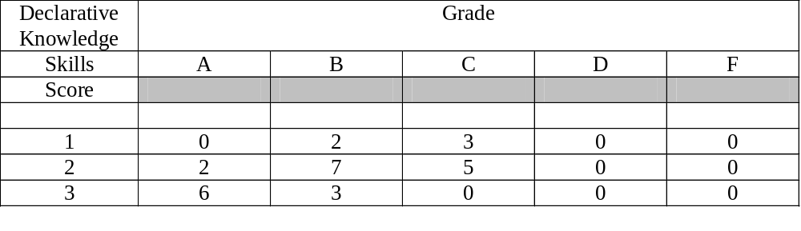________________________________________________________________________________________________________________________________________________________________________________________________________________________

Page 56
Spring 2010Assessment Information
for Management Majors

Spring 2010 Correlations For Management Majors

CT TS WC OC DK
TS .77
WC .69 .75
OC .31 .32 .33
DK .31 .21 .12 .38
Grade .57 .52 .49 .51 .45

Spring 2010 Frequencies for Management Majors

CT Frequency__% TS Frequency__% WC Frequency__%
1 34 29 1 31 27 1 31 27
2 39 34 2 42 36 2 41 35
3 43 37 3 42 37 3 44 38

OC Score Frequency__% DK Score Frequency__%
1 17 15 1 32 28
2 49 42 2 57 50
3 50 43 3 26 23

Spring 2010
CHI-SQUARE BY MEASURE and FINAL GRADE
For Management Majors

Critical | Grade
Thinking | A | B | C | D | F
Score
1 | 0 | 14 | 15 | 3 | 2
2 | 6 | 23 | 10 | 0 | 0
3 | 23 | 20 | 0 | 0 | 0

Page 57

Technical | Grade
Skills | A | B | C | D | F
Score
1 | 0 | 13 | 13 | 3 | 2
2 | 8 | 24 | 10 | 0 | 0
3 | 21 | 20 | 2 | 0 | 0

Written Communications | Grade
Skills | A | B | C | D | F
Score
1 | 0 | 12 | 15 | 3 | 1
2 | 5 | 27 | 8 | 0 | 1
3 | 24 | 18 | 2 | 0 | 0

Oral Communications | Grade
Skills | A | B | C | D | F
Score
1 | 1 | 4 | 10 | 0 | 2
2 | 4 | 30 | 12 | 3 | 0
3 | 24 | 23 | 3 | 0 | 0

Declarative Knowledge | Grade
Skills | A | B | C | D | F
Score
1 | 0 | 15 | 12 | 3 | 2
2 | 19 | 27 | 11 | 0 | 0
3 | 10 | 14 | 2 | 0 | 0

________________________________________________________________________________________________________________________________________________

Page 58

Fall 2009Assessment Information
for Management Majors

Fall 2009 Correlations For Management Majors

CT TS WC OC DK
TS .75
WC .66 .57
OC .27 .31 .21
DK .22 .22 .24 .12
Grade .55 .56 .45 .24 .51

Fall 2009 Frequencies for Management Majors

CT Frequency__% TS Frequency__% WC Frequency__%
1 28 21 1 29 22 1 35 27
2 70 53 2 70 53 2 67 51
3 33 25 3 32 24 3 29 22

OC Score Frequency__% DK Score Frequency__%
1 6 5 1 35 27
2 77 61 2 63 49
3 43 34 3 32 25

Fall 2009
CHI-SQUARE BY MEASURE and FINAL GRADE
For Management Majors

Critical | Grade
Thinking | A | B | C | D | F
Score
1 | 1 | 11 | 13 | 2 | 1
2 | 15 | 38 | 15 | 1 | 1
3 | 25 | 6 | 2 | 0 | 0

Page 59

Technical | Grade
Skills | A | B | C | D | F
Score
1 | 1 | 11 | 14 | 2 | 1
2 | 15 | 38 | 15 | 1 | 1
3 | 25 | 6 | 1 | 0 | 0

Written Communications | Grade
Skills | A | B | C | D | F
Score
1 | 2 | 16 | 14 | 2 | 1
2 | 20 | 31 | 14 | 1 | 1
3 | 19 | 8 | 2 | 0 | 0

Oral Communications | Grade
Skills | A | B | C | D | F
Score
1 | 1 | 3 | 2 | 0 | 0
2 | 18 | 31 | 23 | 3 | 2
3 | 18 | 19 | 6 | 0 | 0

Declarative Knowledge | Grade
Skills | A | B | C | D | F
Score
1 | 1 | 13 | 18 | 2 | 1
2 | 21 | 31 | 9 | 1 | 1
3 | 19 | 10 | 3 | 0 | 0

________________________________________________________________________________________________________________________________________________

Page 60
Summer 2009Assessment Information
for Management Majors

Summer 2009 Correlations For Management Majors

CT TS WC OC DK
TS .80
WC .48 .55
OC .13 .17 .37
DK .12 .09 .02 .14
Grade .38 .37 .44 .22 .46

Summer 2009 Frequencies for Management Majors

CT Frequency__% TS Frequency__% WC Frequency__%
1 18 22 1 9 11 1 12 15
2 30 37 2 45 55 2 38 46
3 34 42 3 28 34 3 32 39

OC Score Frequency__% DK Score Frequency__%
1 10 14 1 26 31
2 34 47 2 44 53
3 29 40 3 13 16

Summer 2009
CHI-SQUARE BY MEASURE and FINAL GRADE
For Management Majors

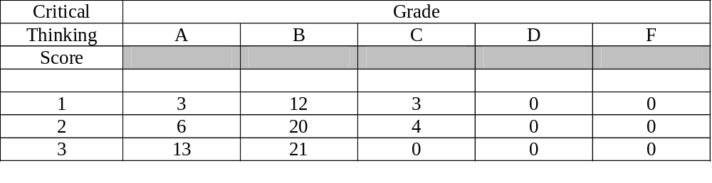

Page 61
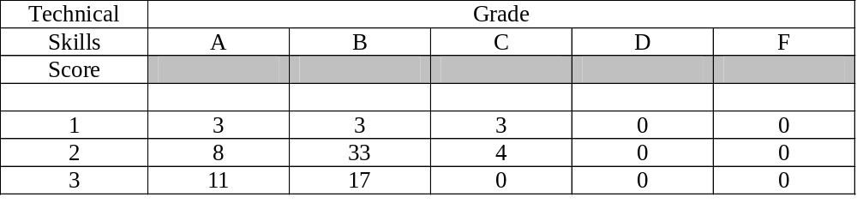
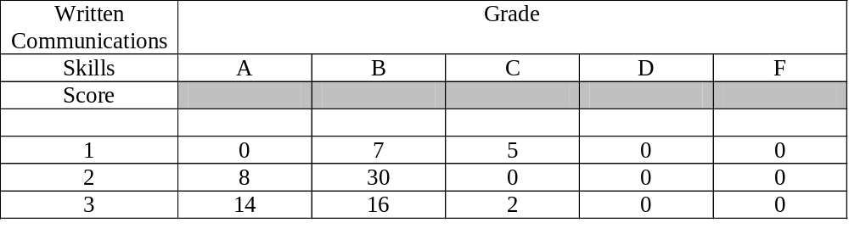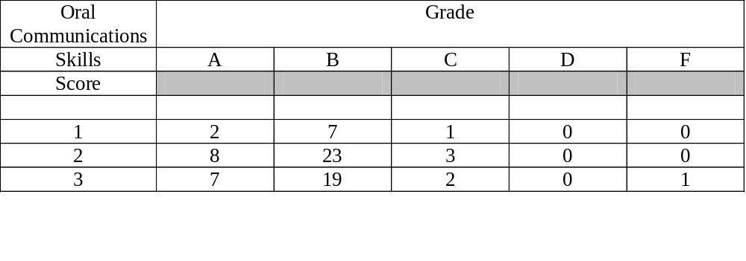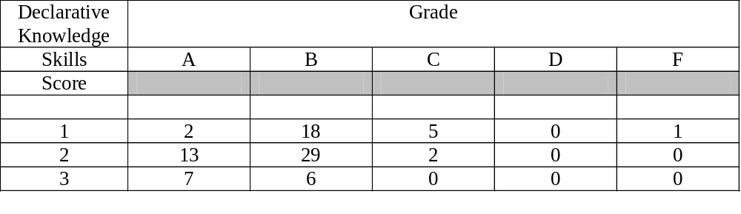________________________________________________________________________________________________________________________________________________

Page 62
Spring 2009 Assessment Information
for Management Majors

Spring 2009 Correlations For Management Majors

CT TS WC OC DK
TS .72
WC .58 .65
OC .23 .25 .38
DK .33 .32 .40 .08
Grade .54 .57 .49 .20 .31

Spring 2009 Frequencies for Management Majors

CT Frequency__% TS Frequency__% WC Frequency__%
1 43 29 1 38 26 1 29 20
2 64 43 2 66 45 2 75 51
3 41 28 3 44 30 3 43 29

OC Score Frequency__% DK Score Frequency__%
1 13 10 1 43 30
2 70 52 2 81 56
3 53 39 3 22 15

Spring 2009
CHI-SQUARE BY MEASURE and FINAL GRADE
For Management Majors

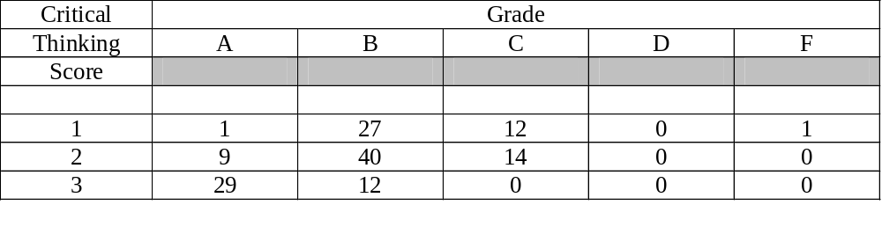

Page 63
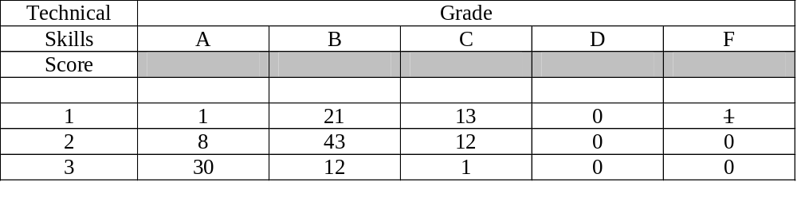
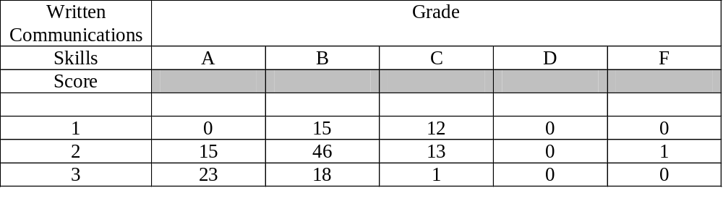
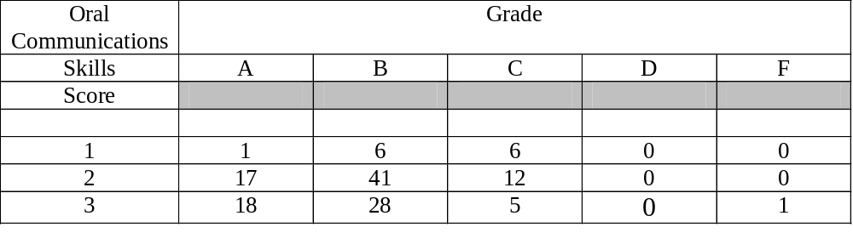
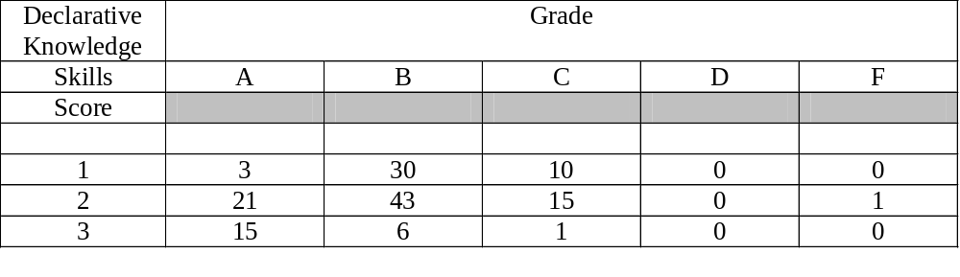
________________________________________________________________________________________________________________________________________________

Page 64
Spring 2010 Assessment Information
for Marketing Majors

Spring 2010 Correlations for Marketing Majors

CT TS WC OC DK
TS .73
WC .60 .61
OC .27 .33 .24
DK .36 .28 .18 .20
Grade .70 .64 .67 .48 .49

Spring 2010 Frequencies for Marketing Majors

CT Frequency__% TS Frequency__% WC Frequency__%
1 19 19 1 19 19 1 19 19
2 40 40 2 47 47 2 38 38
3 41 41 3 34 34 3 43 43

OC Score Frequency__% DK Score Frequency__%
1 19 19 1 23 23
2 40 40 2 54 54
3 42 42 3 23 23

Spring 2010
CHI-SQUARE BY MEASURE and FINAL GRADE
For Marketing Majors

Critical | Grade
Thinking | A | B | C | D | F
Score
1 | 0 | 6 | 8 | 5 | 0
2 | 9 | 22 | 8 | 0 | 1
3 | 21 | 20 | 0 | 0 | 0

Page 65
Technical | Grade
Skills | A | B | C | D | F
Score
1 | 0 | 7 | 7 | 4 | 1
2 | 11 | 26 | 9 | 0 | 0
3 | 19 | 15 | 0 | 0 | 0

Written Communications | Grade
Skills | A | B | C | D | F
Score
1 | 1 | 5 | 8 | 5 | 0
2 | 7 | 24 | 6 | 0 | 1
3 | 22 | 19 | 2 | 0 | 0

Oral Communications | Grade
Skills | A | B | C | D | F
Score
1 | 2 | 7 | 8 | 2 | 0
2 | 6 | 24 | 7 | 3 | 0
3 | 22 | 18 | 2 | 0 | 0

Declarative Knowledge | Grade
Skills | A | B | C | D | F
Score
1 | 0 | 13 | 6 | 4 | 0
2 | 18 | 25 | 10 | 1 | 0
3 | 12 | 10 | 1 | 0 | 0

________________________________________________________________________________________________________________________________________________

Page 66

Fall 2009 Assessment Information
for Marketing Majors

Fall 2009 Correlations for Marketing Majors

CT TS WC OC DK
TS .75
WC .58 .57
OC .02 .04 .07
DK .21 .21 .18 -.01
Grade .50 .43 .45 .15 .50

Fall 2009 Frequencies for Marketing Majors

CT Frequency__% TS Frequency__% WC Frequency__%
1 22 21 1 21 20 1 19 18
2 52 49 2 53 50 2 59 56
3 32 30 3 32 30 3 28 26

OC Score Frequency__% DK Score Frequency__%
1 5 5 1 22 21
2 69 67 2 56 53
3 29 28 3 27 26

Fall 2009
CHI-SQUARE BY MEASURE and FINAL GRADE
For Marketing Majors

Critical | Grade
Thinking | A | B | C | D | F
Score
1 | 1 | 8 | 11 | 1 | 1
2 | 12 | 34 | 5 | 0 | 1
3 | 21 | 10 | 1 | 0 | 0

Page 67
Technical | Grade
Skills | A | B | C | D | F
Score
1 | 1 | 10 | 8 | 1 | 1
2 | 15 | 29 | 8 | 0 | 1
3 | 18 | 13 | 1 | 0 | 0

Written Communications | Grade
Skills | A | B | C | D | F
Score
1 | 2 | 8 | 8 | 0 | 1
2 | 13 | 35 | 9 | 1 | 1
3 | 19 | 9 | 0 | 0 | 0

Oral Communications | Grade
Skills | A | B | C | D | F
Score
1 | 1 | 2 | 2 | 0 | 0
2 | 20 | 34 | 12 | 1 | 2
3 | 11 | 15 | 3 | 0 | 0

Declarative Knowledge | Grade
Skills | A | B | C | D | F
Score
1 | 2 | 9 | 8 | 1 | 2
2 | 16 | 33 | 7 | 0 | 0
3 | 16 | 10 | 1 | 0 | 0

________________________________________________________________________________________________________________________________________________

Page 68

Summer 2009 Assessment Information
for Marketing Majors

Summer 2009 Correlations for Marketing Majors

CT TS WC OC DK
TS .80
WC .47 .42
OC .18 .15 .09
DK .09 .11 .03 .07
Grade .35 .36 .28 .18 .65

Summer 2009 Frequencies for Marketing Majors

CT Frequency__% TS Frequency__% WC Frequency__%
1 15 26 1 9 16 1 7 12
2 23 40 2 30 52 2 28 48
3 20 35 3 19 33 3 23 40

OC Score Frequency__% DK Score Frequency__%
1 5 10 1 21 36
2 32 62 2 26 45
3 15 29 3 11 19

Summer 2009
CHI-SQUARE BY MEASURE and FINAL GRADE
For Marketing Majors

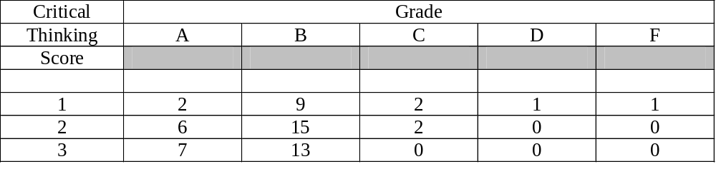

Page 69

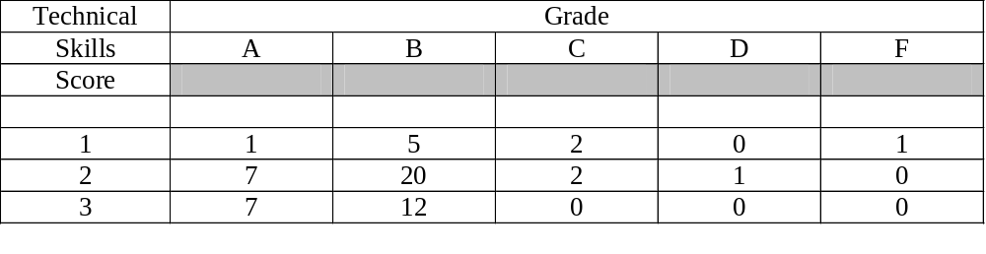
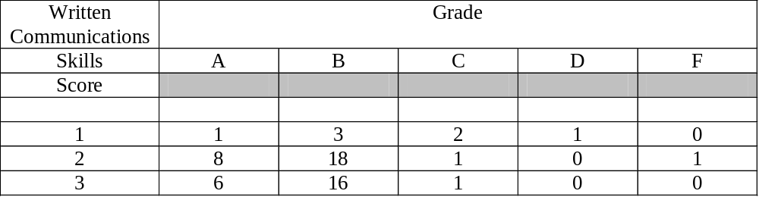
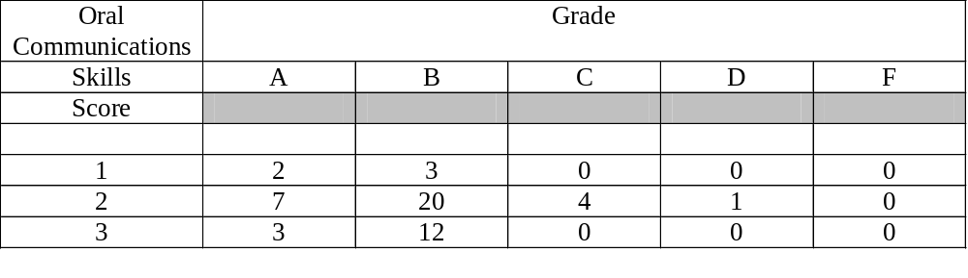
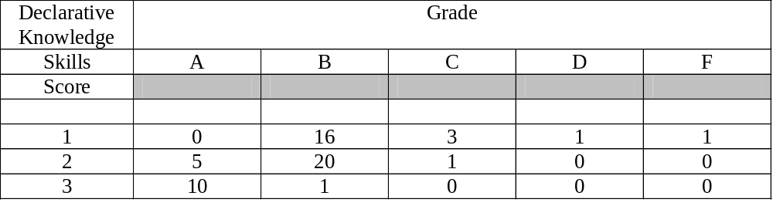________________________________________________________________________________________________________________________________________________

Page 70

Spring 2009 Assessment Information
for Marketing Majors

Spring 2009 Correlations For Marketing Majors

CT TS WC OC DK
TS .77
WC .63 .67
OC .30 .26 .25
DK .30 .24 .31 .07
Grade .65 .55 .52 .36 .39

Spring 2009 Frequencies for Marketing Majors

CT Frequency__% TS Frequency__% WC Frequency__%
1 34 27 1 31 25 1 23 18
2 49 39 2 49 39 2 67 53
3 43 34 3 46 37 3 36 29

OC Score Frequency__% DK Score Frequency__%
1 14 12 1 32 36
2 49 42 2 72 58
3 54 46 3 21 17

Spring 2009
CHI-SQUARE BY MEASURE and FINAL GRADE
For Marketing Majors

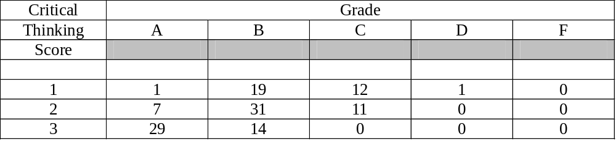page 71
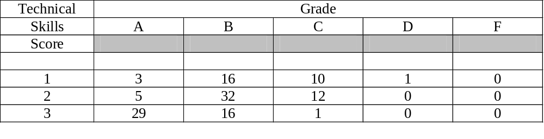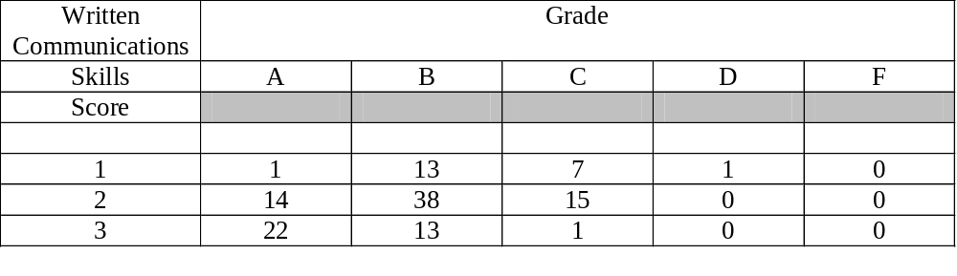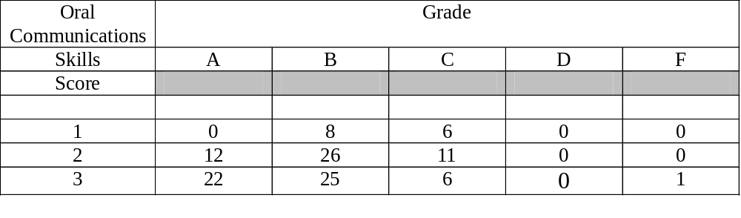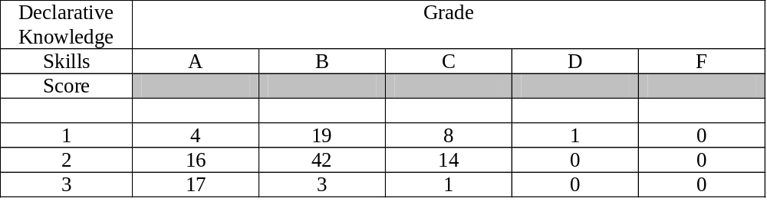________________________________________________________________________ ________________________________________________________________________________________________________________________________________________

Page 72
Spring 2010 Assessment Information
for Small Business Majors

Spring 2010 Correlations for Small Business Majors

CT TS WC OC DK
TS .72
WC .79 .83
OC .19 .00 -.04
DK .60 .58 .64 .40
Grade .55 .64 .75 .21 .95

Spring 2010 Frequencies for Small Business Majors

CT Frequency__% TS Frequency__% WC Frequency__%
1 1 11 1 2 22 1 1 11
2 4 44 2 6 67 2 6 67
3 4 44 3 1 11 3 2 22

OC Score Frequency__% DK Score Frequency__%
1 1 13 1 2 25
2 5 63 2 1 13
3 2 25 3 5 63

Spring 2010
CHI-SQUARE BY MEASURE and FINAL GRADE
For Small Business Majors

Critical | Grade
Thinking | A | B | C | D | F
Score
1 | 0 | 0 | 1 | 0 | 0
2 | 2 | 0 | 1 | 0 | 1
3 | 3 | 1 | 0 | 0 | 0

Page 73

Technical | Grade
Skills | A | B | C | D | F
Score
1 | 0 | 0 | 1 | 0 | 1
2 | 4 | 1 | 1 | 0 | 0
3 | 1 | 0 | 0 | 0 | 0

Written Communications | Grade
Skills | A | B | C | D | F
Score
1 | 0 | 0 | 1 | 0 | 0
2 | 3 | 1 | 1 | 0 | 1
3 | 2 | 0 | 0 | 0 | 0

Oral Communications | Grade
Skills | A | B | C | D | F
Score
1 | 0 | 0 | 1 | 0 | 0
2 | 4 | 0 | 1 | 0 | 0
3 | 1 | 1 | 0 | 0 | 0

Declarative Knowledge | Grade
Skills | A | B | C | D | F
Score
1 | 0 | 0 | 2 | 0 | 0
2 | 0 | 1 | 0 | 0 | 0
3 | 5 | 0 | 0 | 0 | 0

________________________________________________________________________________________________________________________________________________

Page 74
Fall 2009 Assessment Information
for Small Business Majors

Fall 2009 Correlations for Small Business Majors

CT TS WC OC DK
TS .75
WC .57 .34
OC .18 .18 .45
DK .21 .64 .14 .23
Grade .53 .53 .50 .00 .70

Fall 2009 Frequencies for Small Business Majors

CT Frequency__% TS Frequency__% WC Frequency__%
1 5 62 1 5 62 1 3 38
2 2 25 2 2 25 2 3 38
3 1 13 3 1 13 3 2 25

OC Score Frequency__% DK Score Frequency__%
1 0 0 1 4 50
2 5 62 2 2 25
3 3 38 3 2 25

Fall 2009
CHI-SQUARE BY MEASURE and FINAL GRADE
For Small Business Majors

Critical | Grade
Thinking | A | B | C | D | F
Score
1 | 0 | 4 | 1 | 0 | 0
2 | 0 | 1 | 1 | 0 | 0
3 | 1 | 0 | 0 | 0 | 0

Page 75
Technical | Grade
Skills | A | B | C | D | F
Score
1 | 0 | 4 | 1 | 0 | 0
2 | 0 | 1 | 1 | 0 | 0
3 | 1 | 0 | 0 | 0 | 0

Written Communications | Grade
Skills | A | B | C | D | F
Score
1 | 0 | 2 | 1 | 0 | 0
2 | 0 | 2 | 1 | 0 | 0
3 | 1 | 1 | 0 | 0 | 0

Oral Communications | Grade
Skills | A | B | C | D | F
Score
1 | 0 | 0 | 0 | 0 | 0
2 | 0 | 4 | 1 | 0 | 0
3 | 1 | 1 | 1 | 0 | 0

Declarative Knowledge | Grade
Skills | A | B | C | D | F
Score
1 | 0 | 2 | 2 | 0 | 0
2 | 0 | 2 | 0 | 0 | 0
3 | 1 | 1 | 0 | 0 | 0

________________________________________________________________________________________________________________________________________________

Page 76
Summer 2009 Assessment Information
for Small Business Majors

Summer 2009 Correlations for Small Business Majors

CT TS WC OC DK
TS .88
WC .41 .10
OC .41 .10 .17
DK -.13 .13 -.87 .22
Grade .54 .76 -.42 .33 .73

The negative correlations may be due to range restriction and the small number of students.

Summer 2009 Frequencies for Small Business Majors

CT Frequency__% TS Frequency__% WC Frequency__%
1 1 20 1 1 20 1 0 0
2 0 0 2 1 20 2 3 60
3 4 80 3 3 60 3 2 40

OC Score Frequency__% DK Score Frequency__%
1 0 0 1 2 40
2 3 60 2 2 40
3 2 40 3 1 20

Summer 2009
CHI-SQUARE BY MEASURE and FINAL GRADE
For Small Business Majors

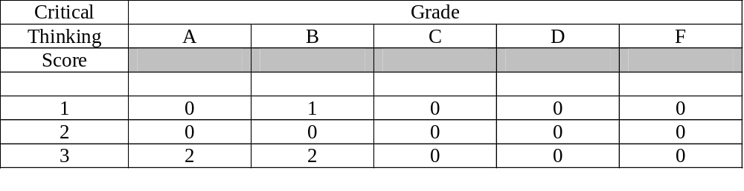page 77
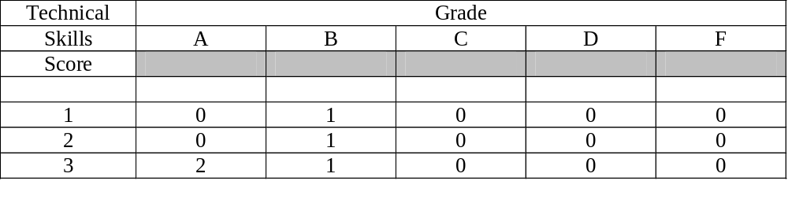

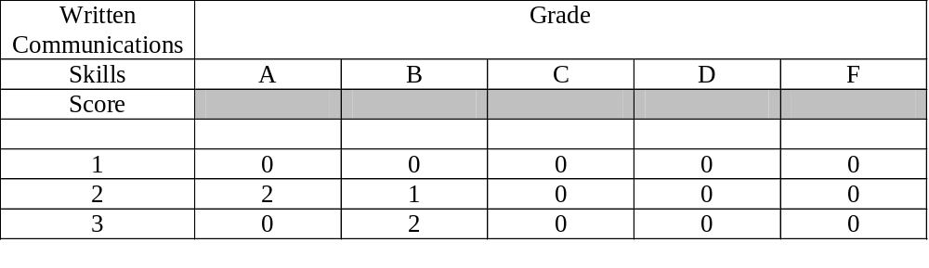
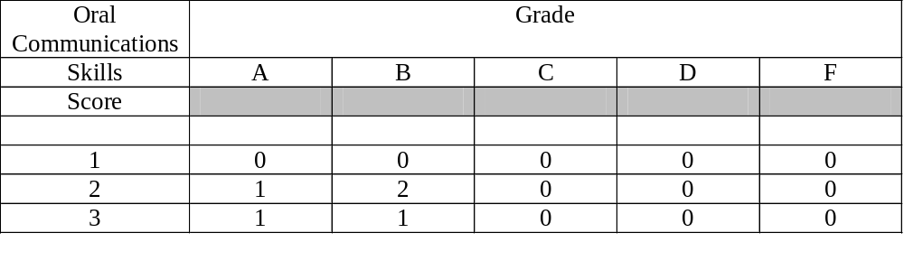

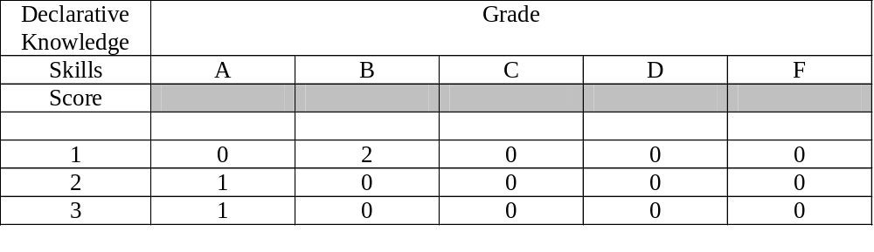________________________________________________________________________________________________________________________________________________

Not enough students in the Spring 2009 to analyze the data.
Page 78

